**Practical No 1**

**Aim: Take a review and write test cases for any known application.**

Zomato

|  |  |  |  |  |  |  |  |
| --- | --- | --- | --- | --- | --- | --- | --- |
| **Name of the Component** | **Testcase ID** | **Test Description** | **Prerequisites** | **Steps and Input** | **Expected Output** | **Actual Output** | **Testcase Remark** |
| Customer Support | TC01 | Verify customer support functionality on Zomato | Access to Zomato website | 1. Navigate to Zomato.com. 2. Click on customer support. 3. Submit query or issue. 4. Receive response or resolution. | Timely response or resolution to customer query. | Customer query resolved satisfactorily. | Customer support system functions effectively. |
| Promotional Offers | TC02 | Verify promotional offers display and redemption on Zomato | Access to Zomato website | 1. Navigate to Zomato.com. 2. View available offers/promotions. 3. Apply offer during checkout. 4. Verify discount applied. | Discount should be applied correctly as per offer terms. | Offer applied successfully with correct discount. | Promotions are displayed and redeemed correctly. |
| Order History | TC03 | Verify order history functionality on Zomato | Access to Zomato website | 1. Navigate to Zomato.com. 2. Go to order history. 3. View past orders. 4. Check order details and status. | Order details and status should be accurately displayed. | Order history displays correct details for each order. | User can view past orders and their details. |
| Menu Navigation | TC04 | Verify menu navigation functionality on Zomato | Access to Zomato website | 1. Navigate to Zomato.com. 2. Select a restaurant. 3. Navigate through menu categories. 4. View menu items and details. | Menu items and details should be easily accessible and accurate. | Menu navigation is intuitive and menu items are displayed correctly. | User can navigate restaurant menus effectively. |
| Mobile Responsiveness | TC05 | Verify mobile responsiveness of Zomato website | Access to Zomato website | 1. Access Zomato.com from mobile device .2. Navigate through various pages .3. Perform actions (search, order, etc.). 4. Verify layout and usability. | Website should display correctly and be easy to use on mobile. | Website layout adjusts appropriately for mobile devices. | Website is responsive and usable on mobile devices. |

**Practical No 2**

**Aim: Implement web drivers on chrome and Firefox browser (chrome, Firefox,choose browser).**

Code:

package Selenium;

import org.openqa.selenium.WebDriver;

import org.openqa.selenium.chrome.ChromeDriver;

import org.openqa.selenium.firefox.FirefoxDriver;

public class Test {

public static void main(String[] args) {

System.setProperty("webdrive.gecko.driver.","C:\\selenium web driver\\ChromeDriver\\chromedriver-win64\\chromedriver-win64\\geckodriver.exe");

WebDriver wd= new FirefoxDriver();

wd.get("http://youtube.com");

}

}

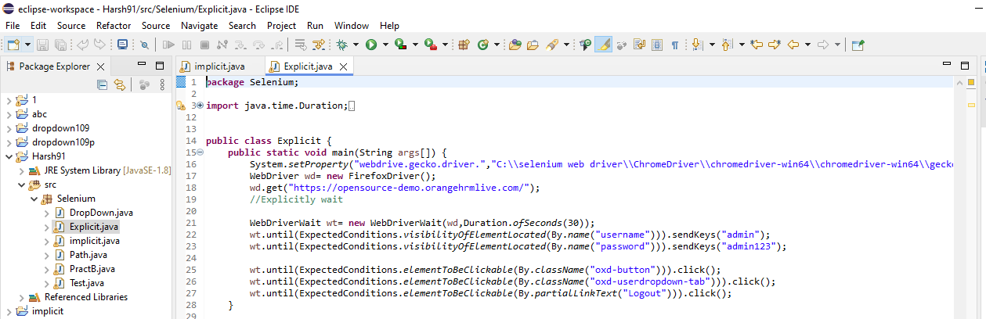

Output:

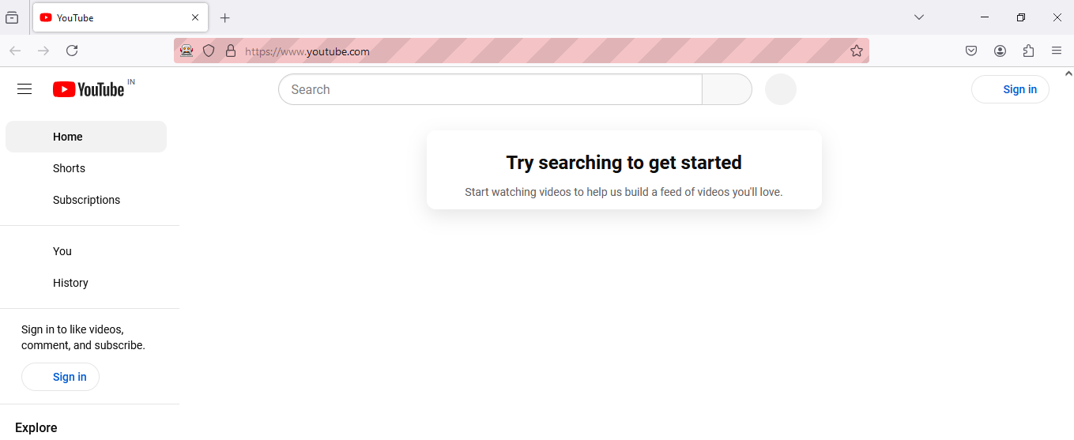

**Firefox Browser**

package pac1;

import org.openqa.selenium.WebDriver;

import org.openqa.selenium.firefox.FirefoxDriver;

public class Prac1a {

public static void main(String[] args) {

System.setProperty("webDriver.chrome.driver", "E:\\Sem3_prac\\STQA\\seleniumweb driver\\GeckoDriver\\geckodriver.exe");

WebDriver wd = new FirefoxDriver();

wd.get("http:\\//google.com");

}

}

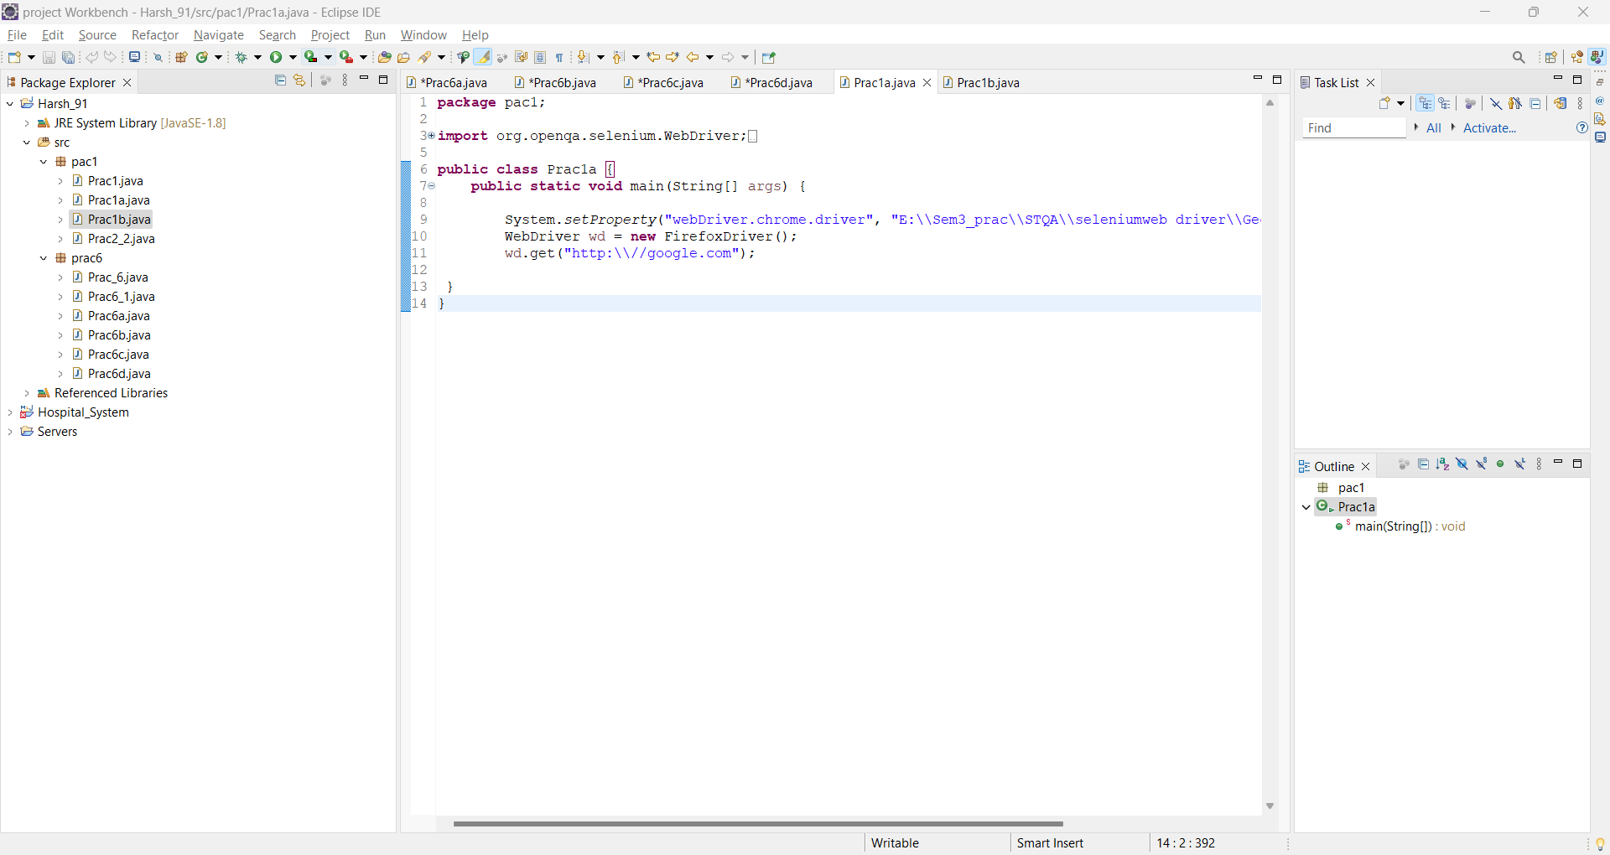

Output:

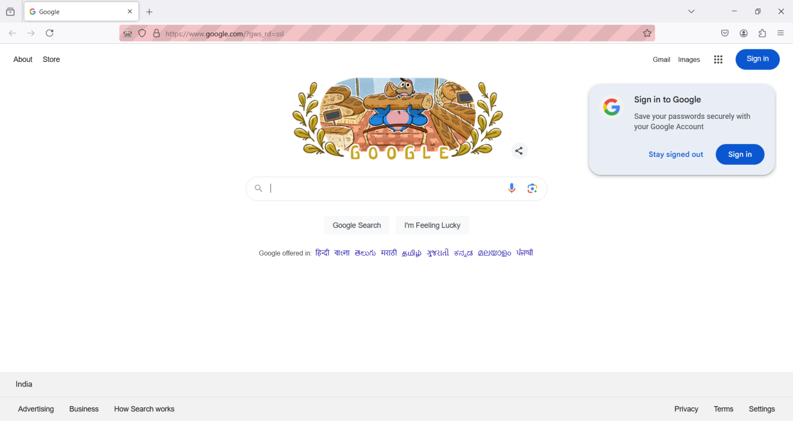

**Choose Browser**

package pac1;

import java.util.Scanner;

import org.openqa.selenium.WebDriver;

import org.openqa.selenium.chrome.ChromeDriver;

import org.openqa.selenium.firefox.FirefoxDriver;

public class Prac1b {

static WebDriver wd;

public static void main(String[] args) {

Scanner sc = new Scanner(System.in);

System.out.println("Rollno 91");

System.out.println("1.Chrome \n 2.Firefox \n");

System.out.println("Choice:");

int ch = sc.nextInt();

sc.close();

switch (ch) {case 1:

System.setProperty("webdriver.chrome.driver","C:\\seleniumweb driver\\ChromeDriver\\chromedriver-win64\\chromedriver-win64\\chromedriver.exe");wd = new ChromeDriver();

break;case 2:

System.setProperty("webdriver.FireFox.driver", "C:\\seleniumweb driver\\GeckoDriver\\geckodriver.exe");wd = new FirefoxDriver();

break;default:

System.out.println("Invalid Choice");

if (wd != null) {wd.get("http://google.com");

}

}

}

}

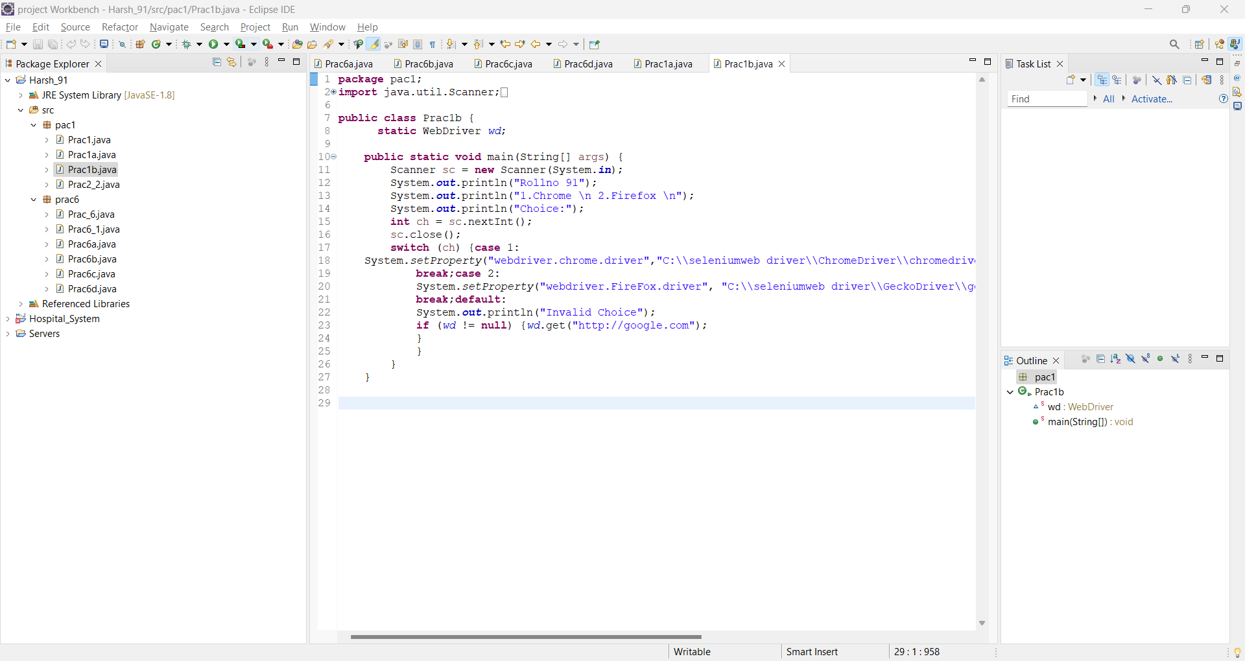

Output:

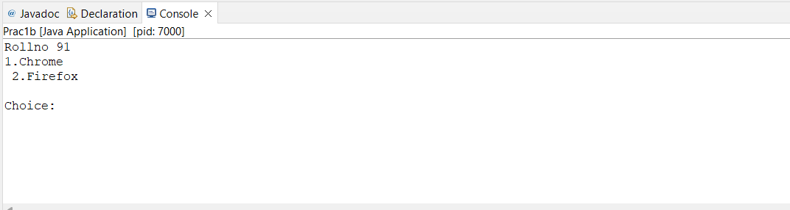

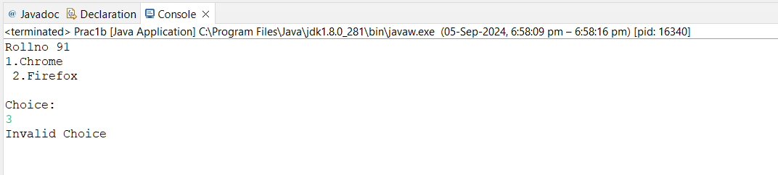

**Practical No: 3**

**Aim:- Demonstrate Handling multiple window in selenium.**

**1) Order Placed**

**Code:**

package pac10;

import org.openqa.selenium.By;

import org.openqa.selenium.WebDriver;

import org.openqa.selenium.firefox.FirefoxDriver;

import org.openqa.selenium.support.ui.Select;

public class Prac10_1 {

public static void main(String[] args) {

System.setProperty("webdriver.chrome.driver","C:\\selenium web driver\\firefox driver\\geckodriver.exe");

WebDriver wd = new FirefoxDriver();

wd.get("https://demo.frontaccounting.eu/");

wd.findElement(By.name("user_name_entry_field")).sendKeys("");

wd.findElement(By.name("password")).sendKeys("");

Select s = new Select (wd.findElement(By.name("company login name")));

wd.findElement(By.name("SubmitUser")).click();

wd.findElement(By.xpath("/html/body/table [1]/tbody/tr/td/table[1]/tbody/tr/td/div[2]/table/tbody/tr[1]/td/table/tbody/tr[2]/td[1]/a[1]")).click();

Select sl = new Select (wd.findElement(By.name("customer_id")));

sl.selectByVisibleText("Donald Easter");

wd.findElement(By.name("AddItem")).click();

wd.findElement(By.name("ProcessOrder")).click();

}

}

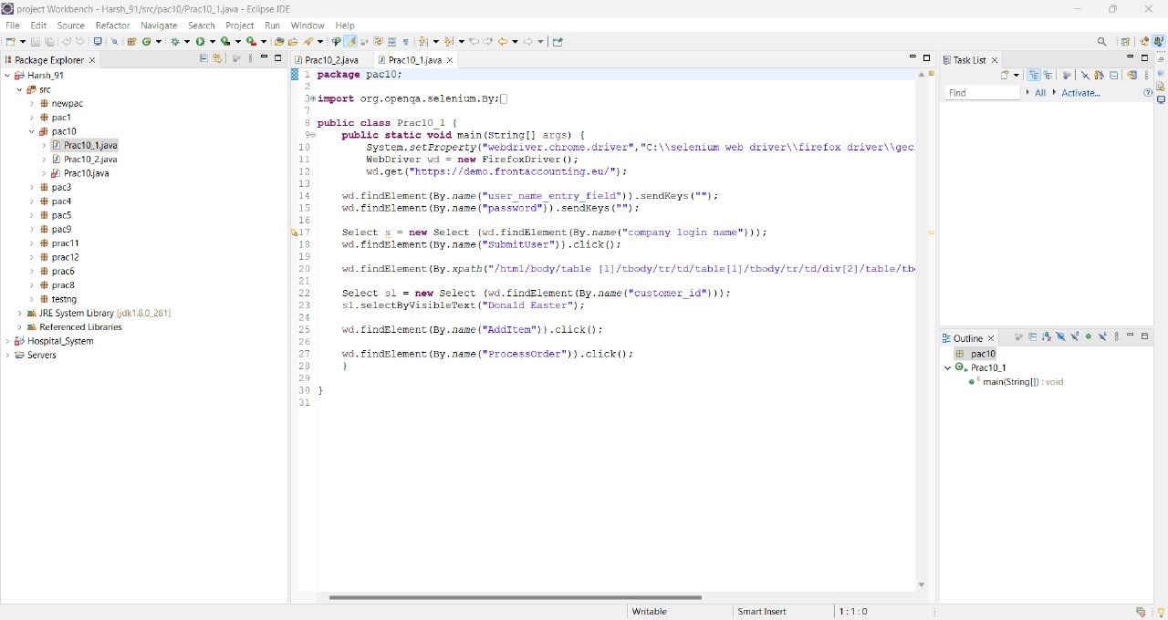

**Output:**

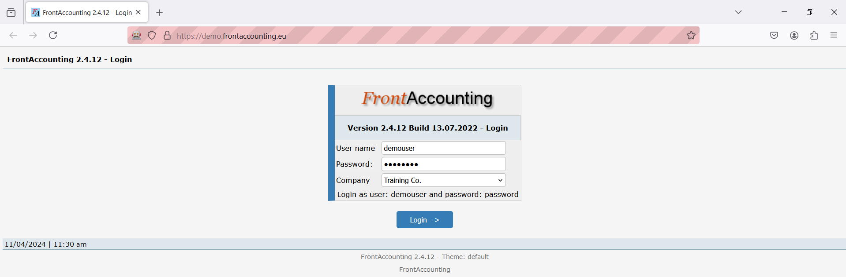

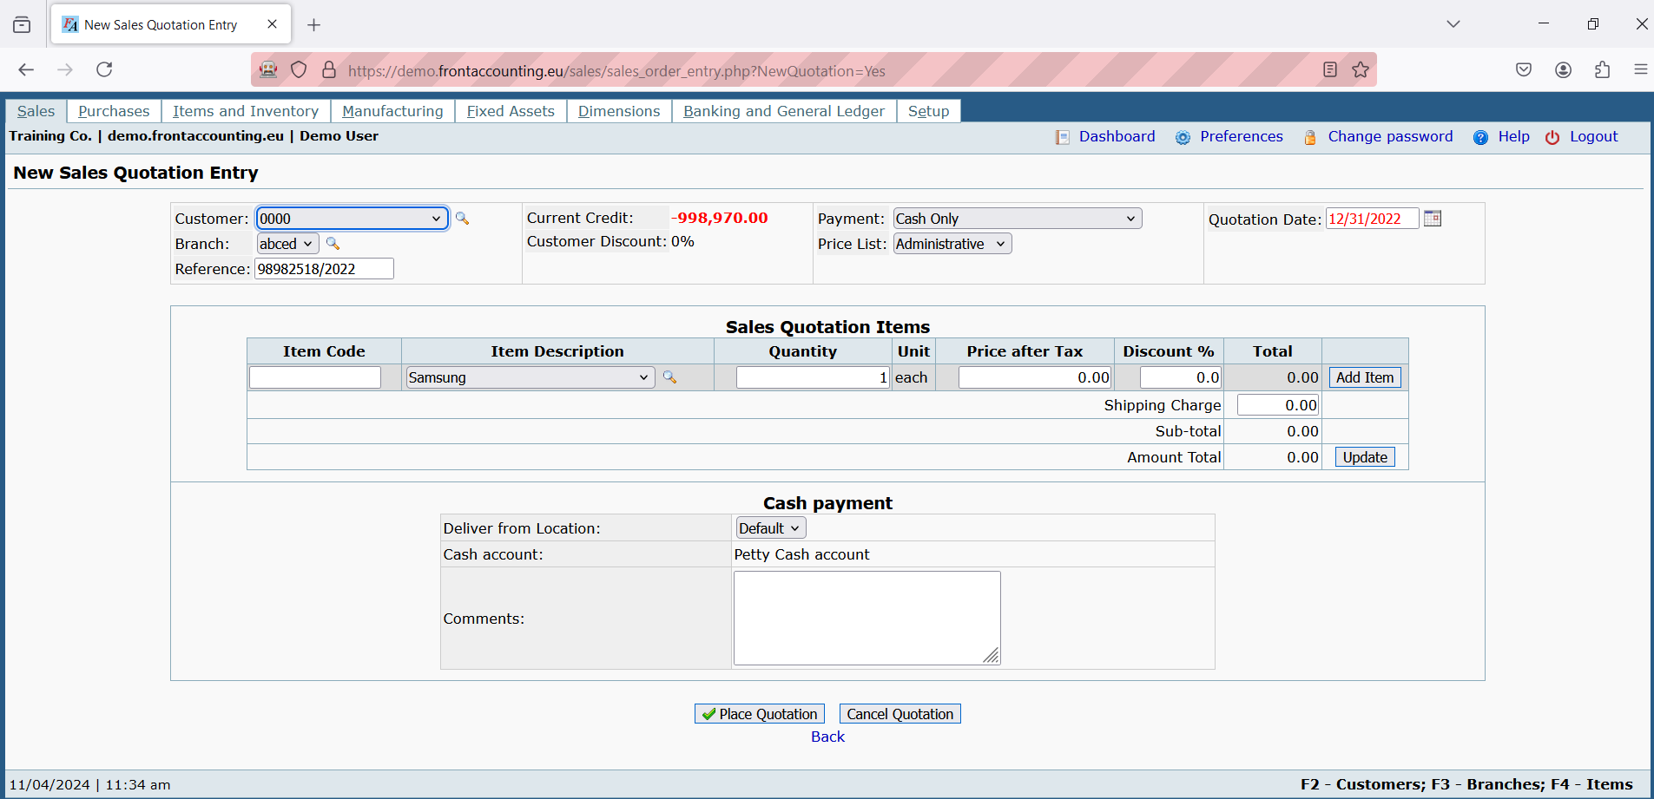

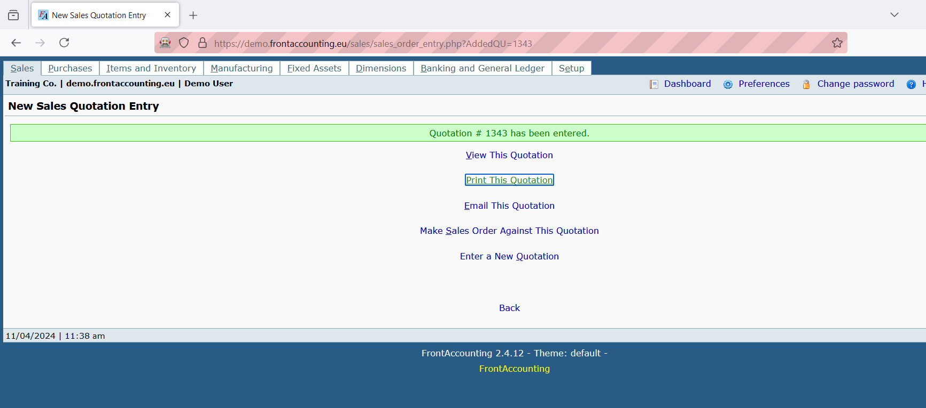

**2) Multiple Window Handling.**

package pac10;

import java.util.Set;

import org.openqa.selenium.By;

import org.openqa.selenium.WebDriver;

import org.openqa.selenium.chrome.ChromeDriver;

import org.openqa.selenium.firefox.FirefoxDriver;

import org.openqa.selenium.support.ui.Select;

public class Prac10_2 {

public static void main(String[] args)

{

System.setProperty("webdriver.chrome.driver", "D:\\Selenium\\chromedriver-win64\\chromedriver.exe");

WebDriver wd=new FirefoxDriver();

wd.get("https://demo.frontaccounting.eu/");

wd.findElement(By.name("user_name_entry_field")).sendKeys("");

wd.findElement(By.name("password")).sendKeys("");

Select s= new Select (wd.findElement(By.name("company_login_name")));

wd.findElement(By.name("SubmitUser")).click();

wd.findElement(By.xpath("/html/body/table[1]/tbody/tr/td/table[l]/tbody/tr/td/div[2]/table/tbody/tr[1]/td/table/tbody/tr[2]/td[1]/a[1]")).click();

String Pid= wd.getWindowHandle();

System.out.println("Parent Window >" + Pid);

wd.findElement(By.xpath("/html/body/table[1]/tbody/tr/td/table[1]/tbody/tr/td/div[2]/form/center[1]/table/tbody/tr/td[2]/table/tbody/tr[1]/td[2]/a")).click();

Set<String> allwin = wd.getWindowHandles();

{

for (String W:allwin) {

wd.switchTo().window(W);

System.out.println(wd.getTitle());

if(!(W.equals(Pid)))

{

Select ss = new Select (wd.findElement(By.id("customer_id")));

ss.selectByVisibleText("Donald Easter");

wd.manage().window().maximize();

wd.close();

}

wd.switchTo().window (Pid);

wd.findElement(By.linkText("Logout")).click();

//wd.close();

}}}}

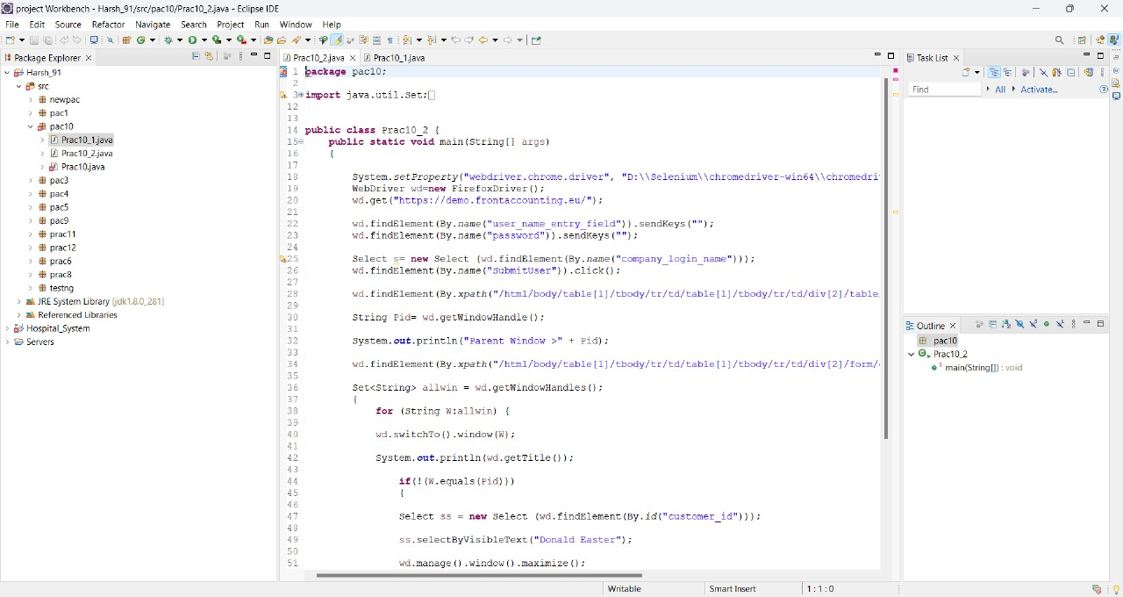

**Output:**



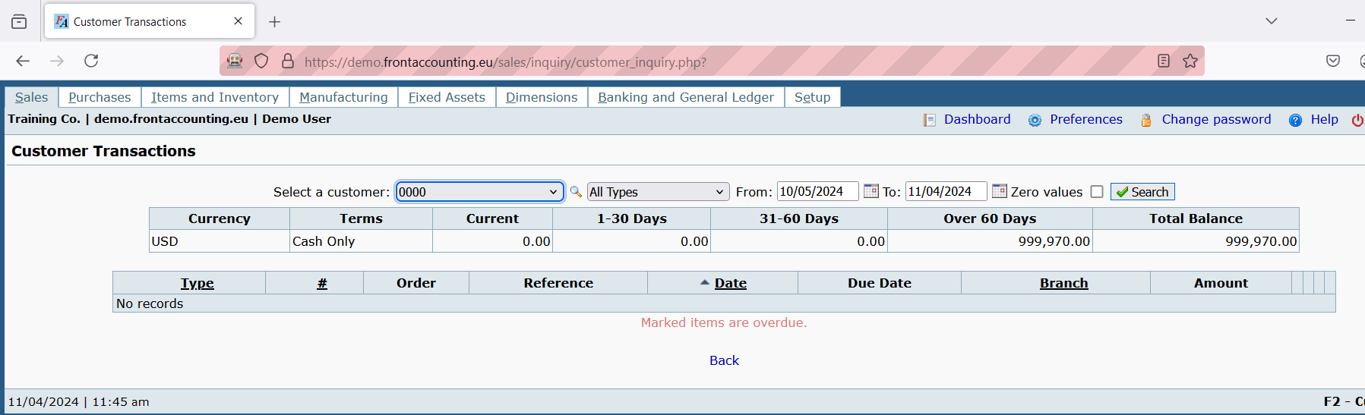

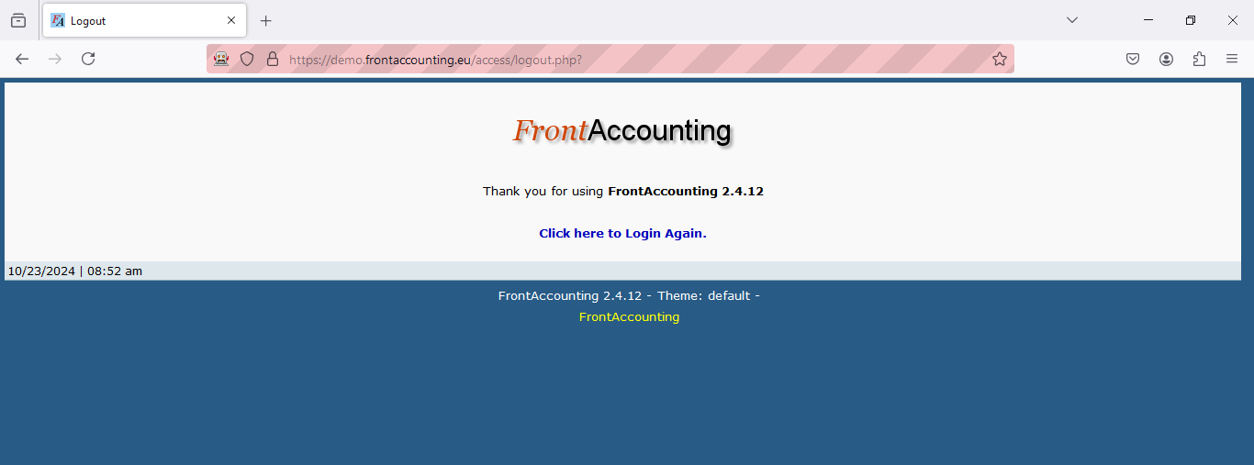

**Practical No: 4**

**Aim: Implement Browser command and navigation commands**

**Code:**

package pac4;

import org.openqa.selenium.By;

import org.openqa.selenium.WebDriver;

import org.openqa.selenium.chrome.ChromeDriver;

public class Prac4_1 {

public static void main(String[] args)throws Exception {

System.setProperty("webdriver.gecko.driver","C:\\selenium web driver\\geckodriver.exe");

WebDriver wd=new ChromeDriver();

wd.get("https://opensource-demo.orangehrmlive.com");Thread.sleep(2000);

wd.findElement(By.cssSelector("input[name=username]")).sendKeys("admin");

wd.findElement(By.cssSelector("input[name=password]")).sendKeys("admin123");

wd.findElement(By.cssSelector("button[type=Submit]")).click();

}

}

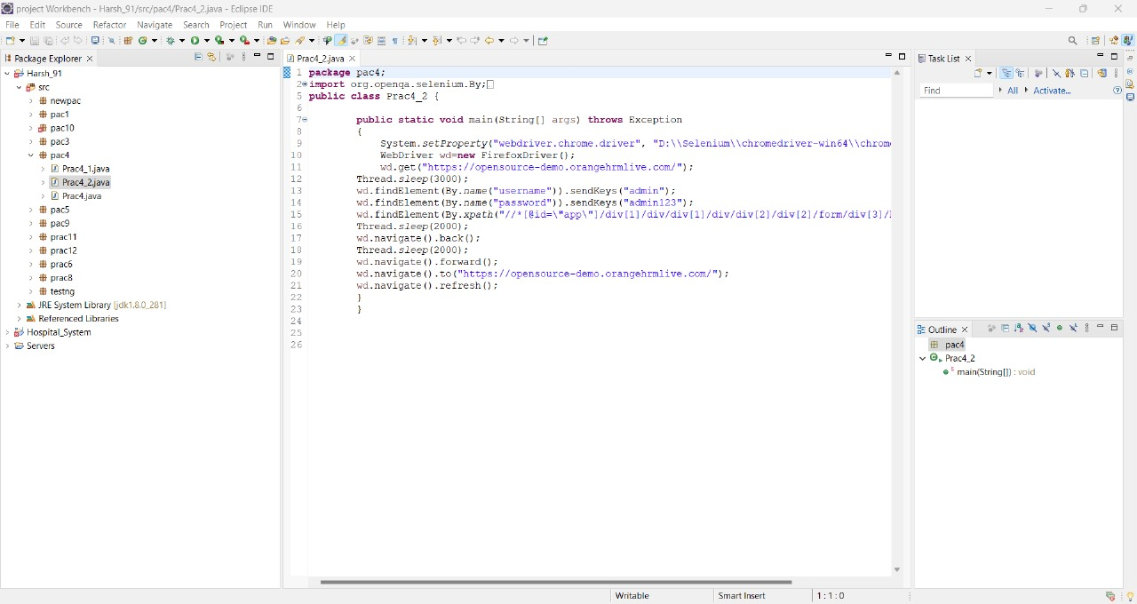

**Output:**

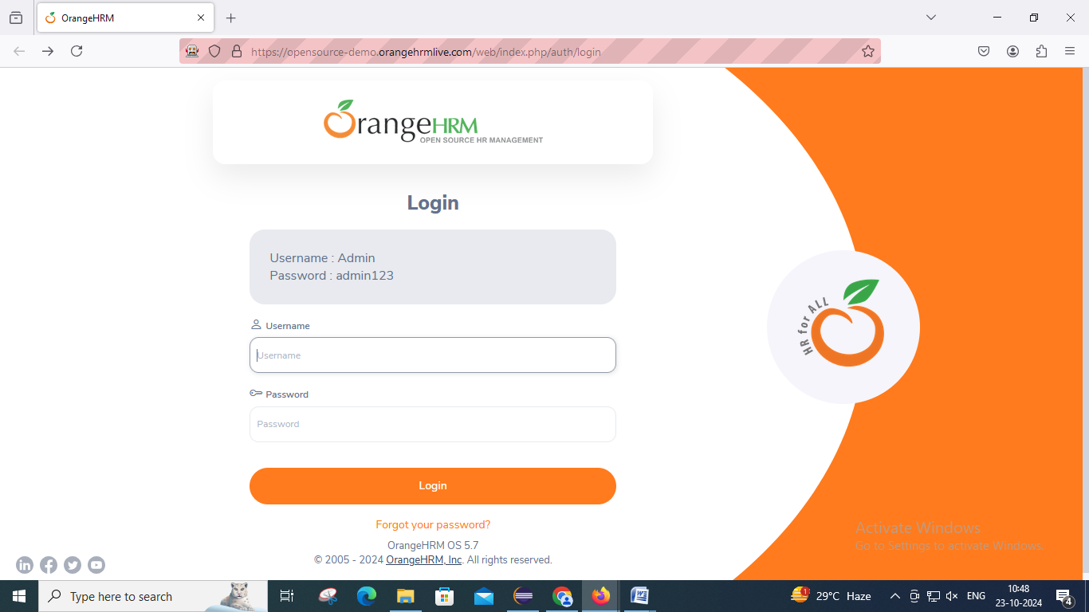

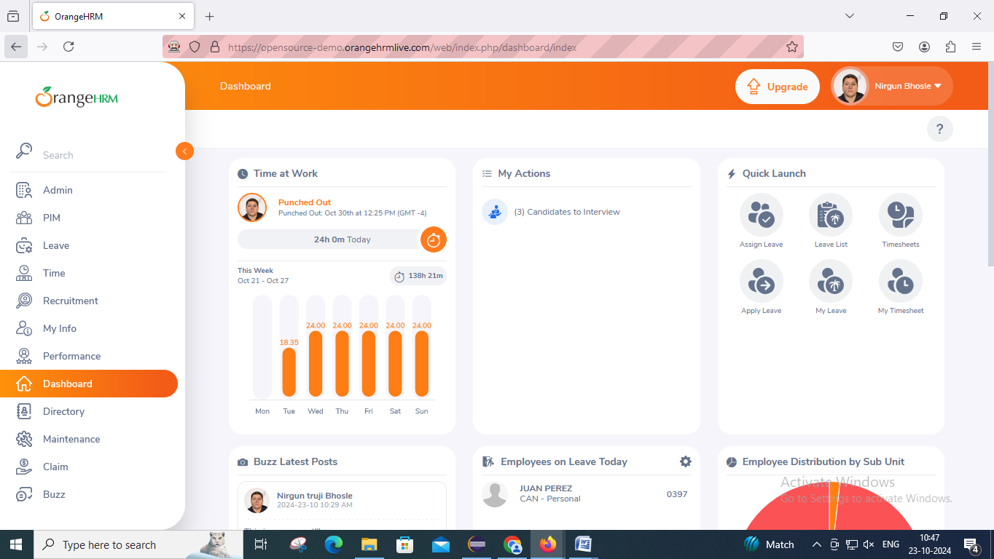

**Practical No: 5**

**Aim: Implement the find element command.**

**Code:**

**package** pac4;

**import** org.openqa.selenium.By;

**import** org.openqa.selenium.WebDriver;

**import** org.openqa.selenium.chrome.ChromeDriver;

**public** **class** Prac4 {

**public** **static** **void** main(String[] args) **throws** Exception{

// **TODO** Auto-generated method stub

System.*setProperty*("webdriver.chrome.driver", "D:\\Selenium\\chromedriver-win64\\chromedriver.exe");

WebDriver wd = **new** ChromeDriver();

wd.get("https://opensource-demo.orangehrmlive.com/");

Thread.*sleep*(2000);

wd.findElement(By.*xpath*("//*[@id=\"app\"]/div[1]/div/div[1]/div/div[2]/div[2]/form/div[1]/div/div[2]/input")).sendKeys("admin");

wd.findElement(By.*xpath*("//*[@id=\"app\"]/div[1]/div/div[1]/div/div[2]/div[2]/form/div[2]/div/div[2]/input")).sendKeys("admin123");

wd.findElement(By.*xpath*("//*[@id=\"app\"]/div[1]/div/div[1]/div/div[2]/div[2]/form/div[3]/button")).click();

}}

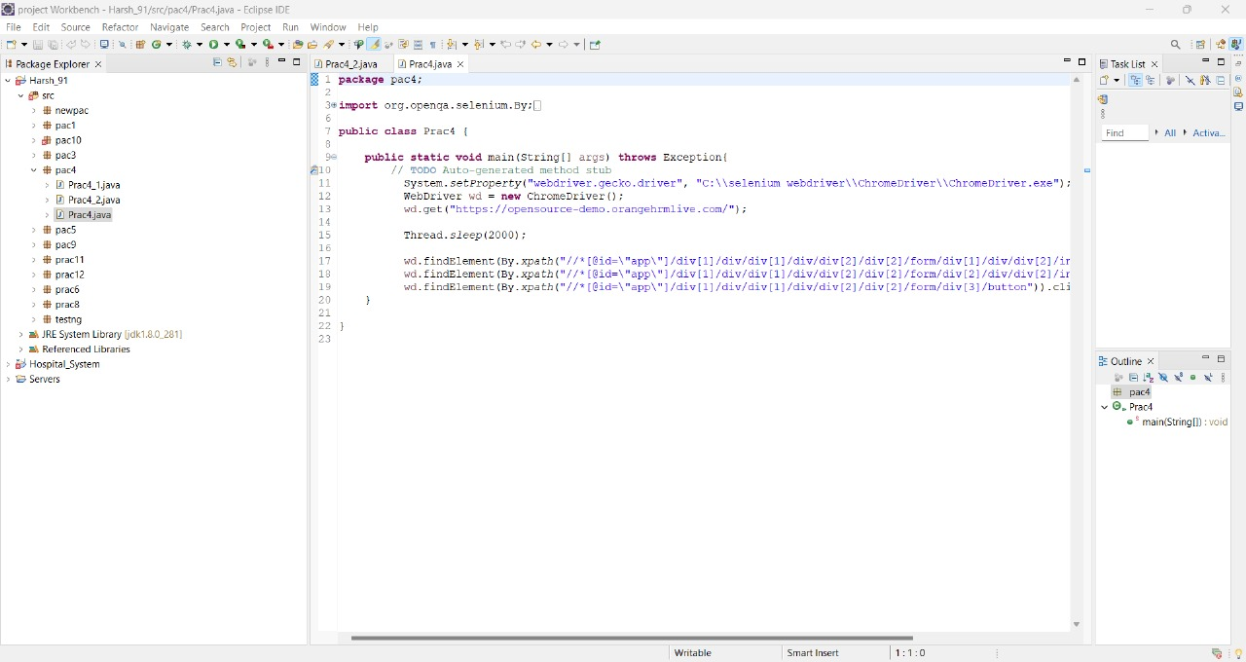

**Output:**

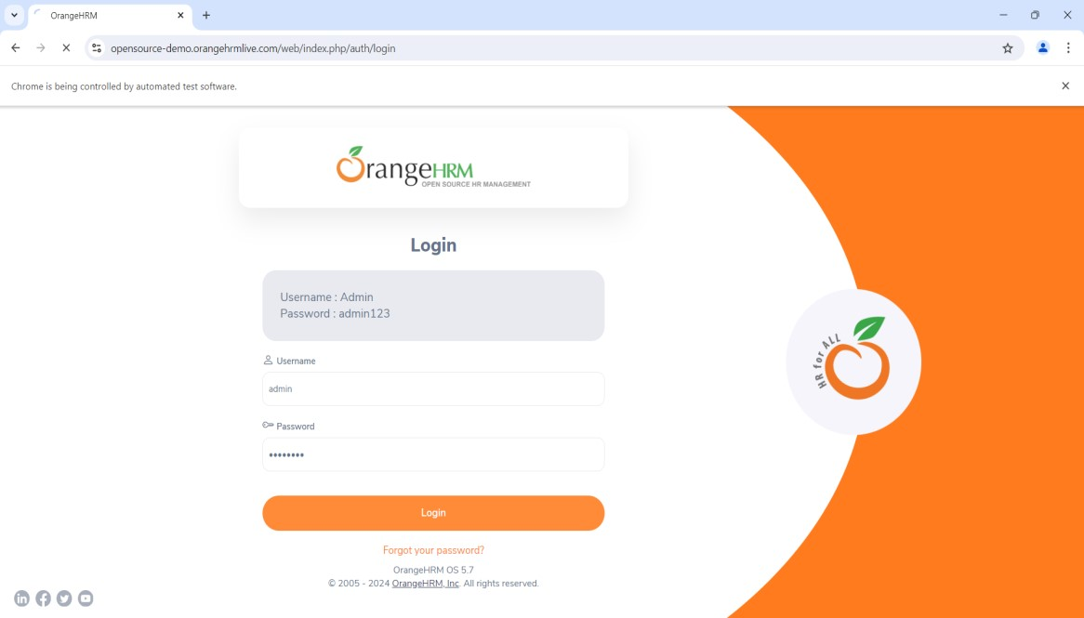

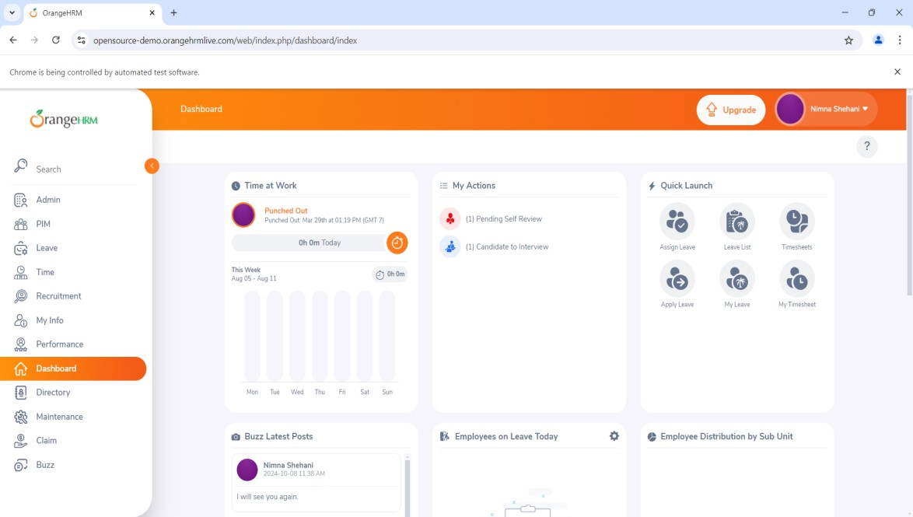

**Practical No 6**

**Aim: Demonstrate the locator (byname, css selector, Xpath,path)**

**Byname**

Code:

package Selenium;

import org.openqa.selenium.By;

import org.openqa.selenium.WebDriver;

import org.openqa.selenium.firefox.FirefoxDriver;

public class Path {

public static void main(String args[]) throws Exception {

System.setProperty("webdrive.gecko.driver.","C:\\selenium web driver\\ChromeDriver\\chromedriver-win64\\chromedriver-win64\\geckodriver.exe");

WebDriver wd= new FirefoxDriver();

wd.get("https://opensource-demo.orangehrmlive.com/");

Thread.sleep(2000);

wd.findElement(By.xpath("/html/body/div/div[1]/div/div[1]/div/div[2]/div[2]/form/div[1]/div/div[2]/input")).sendKeys("Admin");

wd.findElement(By.xpath("/html/body/div/div[1]/div/div[1]/div/div[2]/div[2]/form/div[2]/div/div[2]/input")).sendKeys("admin123");

wd.findElement(By.xpath("/html/body/div/div[1]/div/div[1]/div/div[2]/div[2]/form/div[3]/button")).click();

}

}



Output:

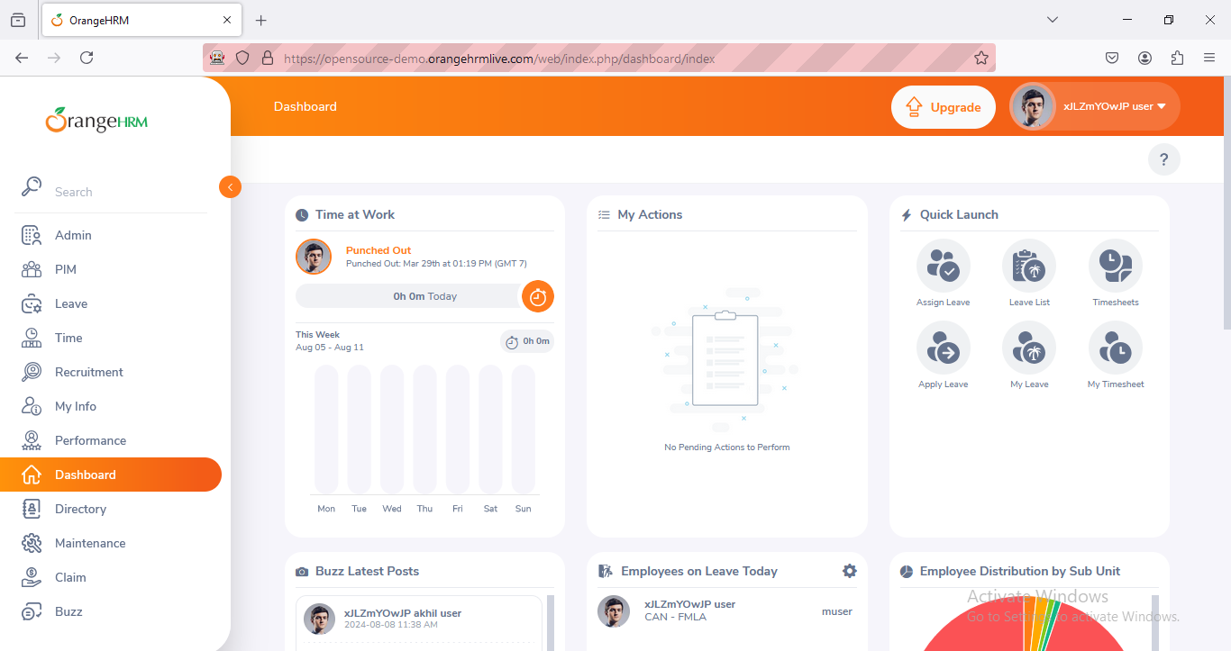

**By CSS Selector**

Code:

package Selenium;

import java.util.concurrent.TimeUnit;

import org.openqa.selenium.By;

import org.openqa.selenium.WebDriver;

import org.openqa.selenium.chrome.ChromeDriver;

import org.openqa.selenium.chrome.ChromeDriver;

import org.openqa.selenium.support.ui.WebDriverWait;

public class Pract3

{

public static void main(String[] args)throws Exception

{

System.setProperty("webdriver.gecko.driver","C:\\selenium web driver\\geckodriver.exe");

WebDriver wd=new ChromeDriver();

wd.get("https://opensource-demo.orangehrmlive.com");

Thread.sleep(2000);

wd.findElement(By.cssSelector("input[name=username]")).sendKeys("admin");

wd.findElement(By.cssSelector("input[name=password]")).sendKeys("admin123");

wd.findElement(By.cssSelector("button[type=Submit]")).click();

}

}



**Output:**

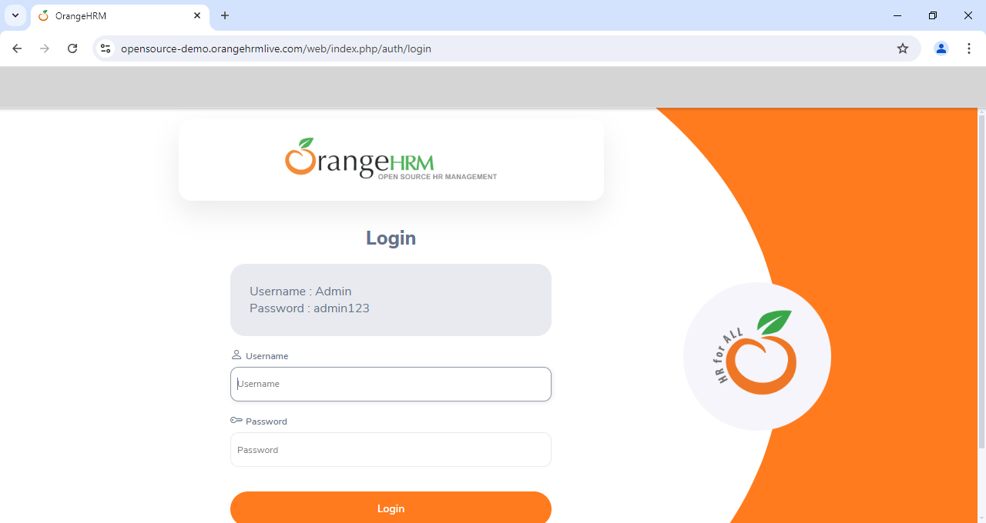

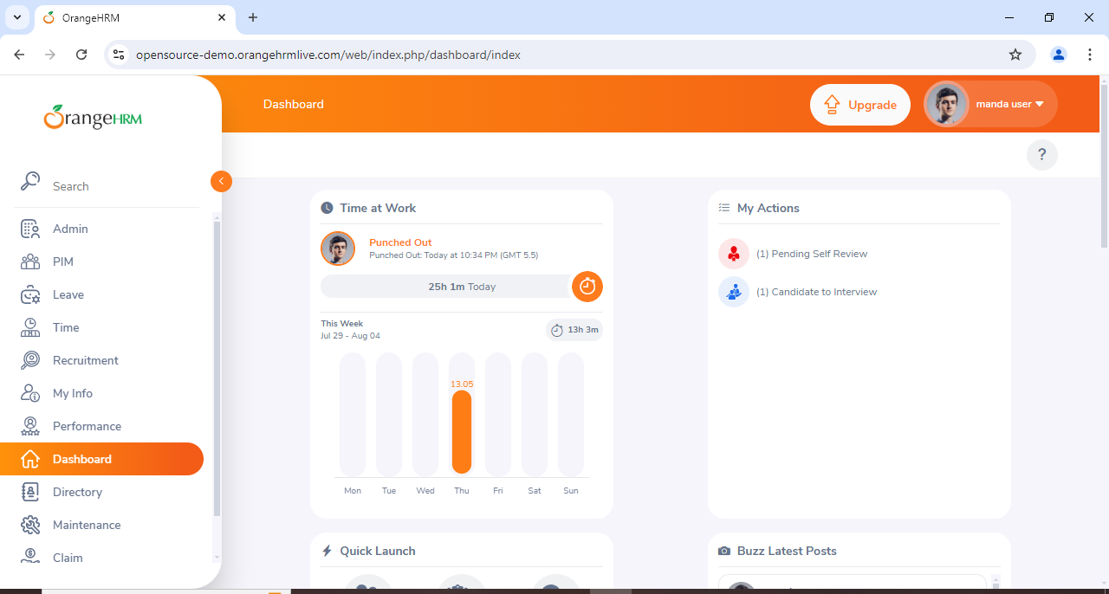

**By Xpath**

**Code:**

package Selenium;

import org.openqa.selenium.By;

import org.openqa.selenium.WebDriver;

import org.openqa.selenium.firefox.FirefoxDriver;

public class xpath {

public static void main(String[] args) throws Exception{

// TODO Auto-generated method stub

System.setProperty("webdriver.gecko.driver", "C:\\seleniumweb driver\\GeckoDriver\\geckodriver.exe");

WebDriver wd = new FirefoxDriver();

wd.get("https://opensource-demo.orangehrmlive.com/");

Thread.sleep(2000); wd.findElement(By.xpath("//*[@id=\"app\"]/div[1]/div/div[1]/div/div[2]/div[2]/form/div[1]/div/div[2]/input")).sendKeys("admin"); wd.findElement(By.xpath("//*[@id=\"app\"]/div[1]/div/div[1]/div/div[2]/div[2]/form/div[2]/div/div[2]/input")).sendKeys("admin123"); wd.findElement(By.xpath("//*[@id=\"app\"]/div[1]/div/div[1]/div/div[2]/div[2]/form/div[3]/button")).click();

}

}



**Output:**

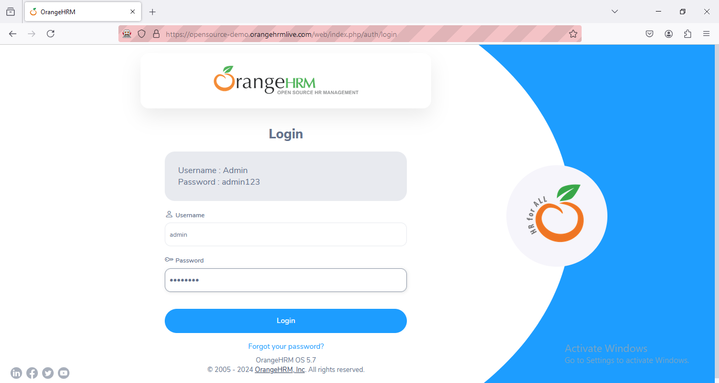

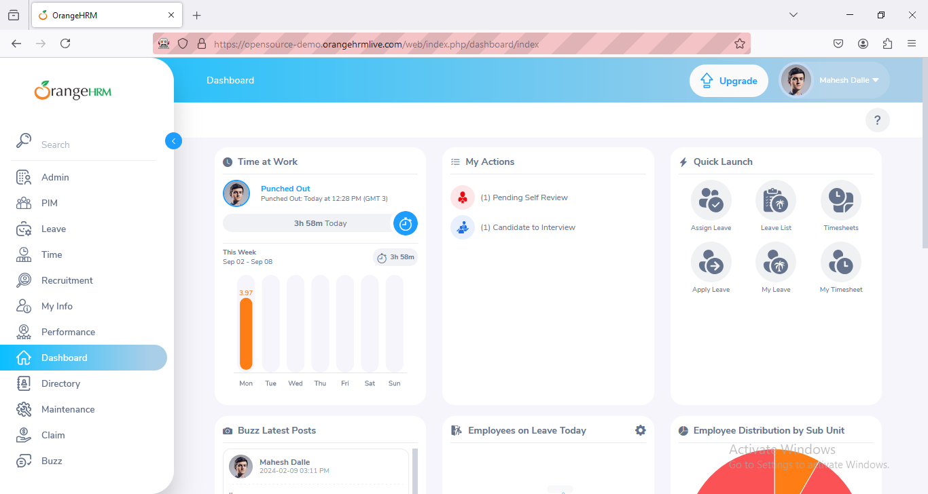

**Practical No 7**

**Aim: Demonstrate synchronisation in selenium (Implicitly wait, explicitly wait)**

**Implicitly wait**

Code:

package Selenium;

import java.util.concurrent.TimeUnit;

import org.openqa.selenium.By;

import org.openqa.selenium.WebDriver;

import org.openqa.selenium.chrome.ChromeDriver;

import org.openqa.selenium.firefox.FirefoxDriver;

import org.openqa.selenium.support.ui.WebDriverWait;

public class implicit

{

public static void main(String[] args)

{

//System.setProperty("webdriver.chrome.driver","E:\\\\chromedriver-win64\\\\chromedriver.exe");

System.setProperty("webdrive.gecko.driver.","C:\\selenium web driver\\ChromeDriver\\chromedriver-win64\\chromedriver-win64\\geckodriver.exe");

//WebDriver wd=new ChromeDriver();

WebDriver wd= new FirefoxDriver();

wd.get("https://opensource-demo.orangehrmlive.com/");

wd.manage().timeouts().implicitlyWait(10,TimeUnit.SECONDS);

wd.findElement(By.name("Username")).sendKeys("Admin");//locator id

wd.findElement(By.name("Password")).sendKeys("Admin123");//locator name

wd.findElement(By.className("oxd-button")).click();//locator classname

wd.close();

}

}



Output:

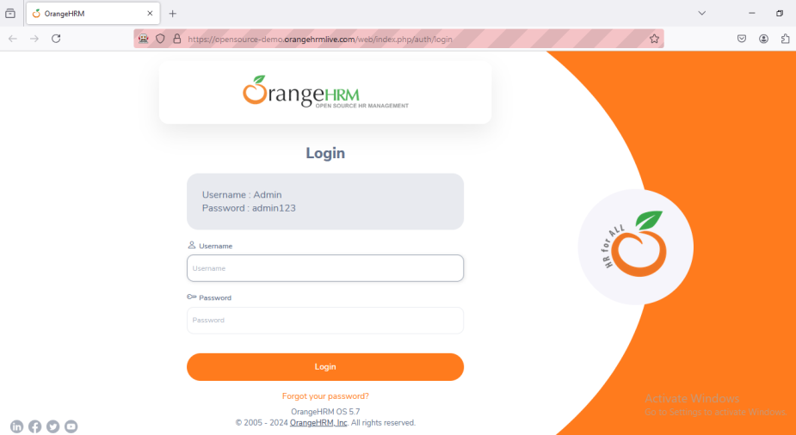

**Explicitly wait**

Code:

package Selenium;

import java.time.Duration;

import java.util.concurrent.TimeUnit;

import org.openqa.selenium.By;

import org.openqa.selenium.WebDriver;

import org.openqa.selenium.chrome.ChromeDriver;

import org.openqa.selenium.firefox.FirefoxDriver;

import org.openqa.selenium.support.ui.ExpectedConditions;

import org.openqa.selenium.support.ui.WebDriverWait;

public class Explicit {

public static void main(String args[]) {

System.setProperty("webdrive.gecko.driver.","C:\\selenium web driver\\ChromeDriver\\chromedriver-win64\\chromedriver-win64\\geckodriver.exe");

WebDriver wd= new FirefoxDriver();

wd.get("https://opensource-demo.orangehrmlive.com/");

//Explicitly wait

WebDriverWait wt= new WebDriverWait(wd,Duration.ofSeconds(30));

wt.until(ExpectedConditions.visibilityOfElementLocated(By.name("username"))).sendKeys("admin");

wt.until(ExpectedConditions.visibilityOfElementLocated(By.name("password"))).sendKeys("admin123");

wt.until(ExpectedConditions.elementToBeClickable(By.className("oxd-button"))).click();

wt.until(ExpectedConditions.elementToBeClickable(By.className("oxd-userdropdown-tab"))).click();

wt.until(ExpectedConditions.elementToBeClickable(By.partialLinkText("Logout"))).click();

}

}



Output:

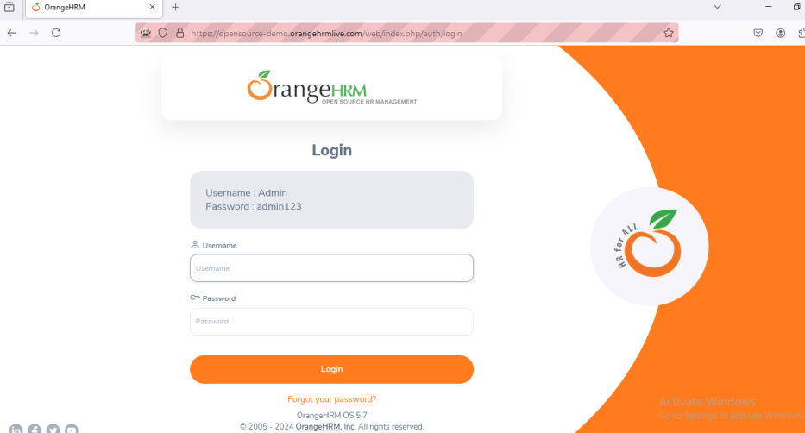

**Practical No: 8**

**Aim: Demonstrate Different types of alerts.**

**Code:**

package pac10;

import org.openqa.selenium.By;

import org.openqa.selenium.WebDriver;

import org.openqa.selenium.firefox.FirefoxDriver;

import org.openqa.selenium.support.ui.Select;

public class Prac10 {

public static void main(String[] args) {

// TODO Auto-generated method stub

System.setProperty("webdriver.chrome.driver","C:\\selenium web driver\\firefox driver\\geckodriver.exe");

WebDriver wd = new FirefoxDriver();

wd.get("https://demo.frontaccounting.eu/");

wd.findElement(By.name("user_name_entry_field")).sendKeys("");

wd.findElement(By.name("password")).sendKeys("");

Select s = new Select(wd.findElement(By.name("company_login_name")));

wd.findElement(By.name("SubmitUser")).click(); wd.findElement(By.xpath("/html/body/table[1]/tbody/tr/td/table[l]/tbody/tr/td/div[2]/table/tbody/tr[1]/td/table/tbody/tr[2]/td[1]/a[l]")).click();

String Pid = wd.getWindowHandle();

System.out.println("Parent Window >" + Pid);

Select sl = new Select (wd.findElement(By.name("customer_id")));

sl.selectByVisibleText ("Donald Easter");

wd.findElement(By.name("CancelOrder")).click();

}

}

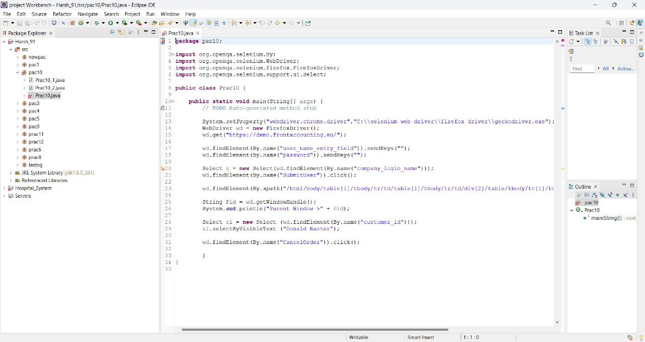

**Output:**

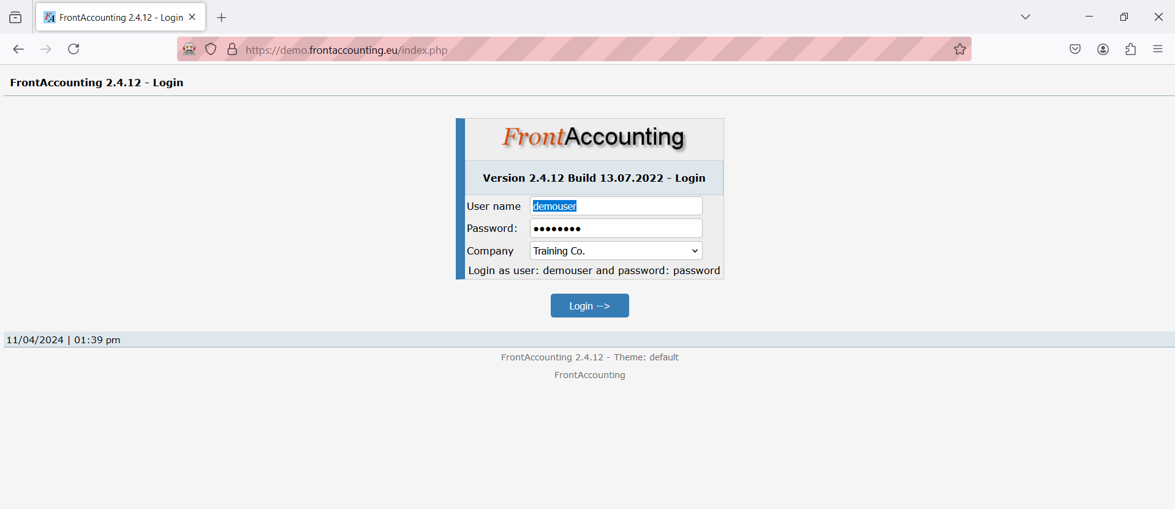

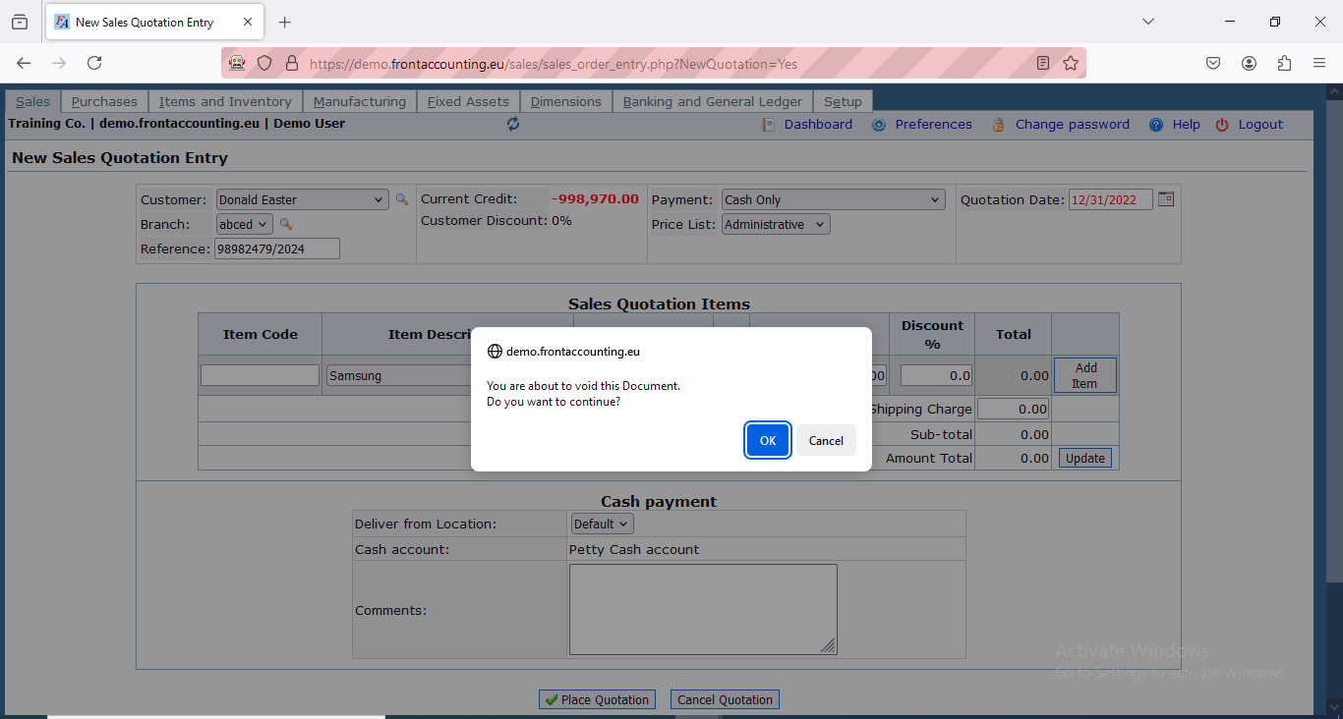

**Practical No 9**

**Aim: Demonstrate handling drop down list ( Byindex, bytext, byvalue)**

**By text**

Code:

package Selenium;

import org.openqa.selenium.By;

import org.openqa.selenium.WebDriver;

import org.openqa.selenium.firefox.FirefoxDriver;

import org.openqa.selenium.support.ui.Select;

public class DropDown {

public static void main(String[] args)throws Exception {

System.setProperty("webdriver.gecko.driver","C:\\selenium web driver\\geckodriver\\geckodriver.exe");

WebDriver wd=new FirefoxDriver();

wd.get("https://blazedemo.com/");

Thread.sleep(2000);

Select s = new Select(wd.findElement(By.name("fromPort")));

s.selectByValue("San Diego");

}

}

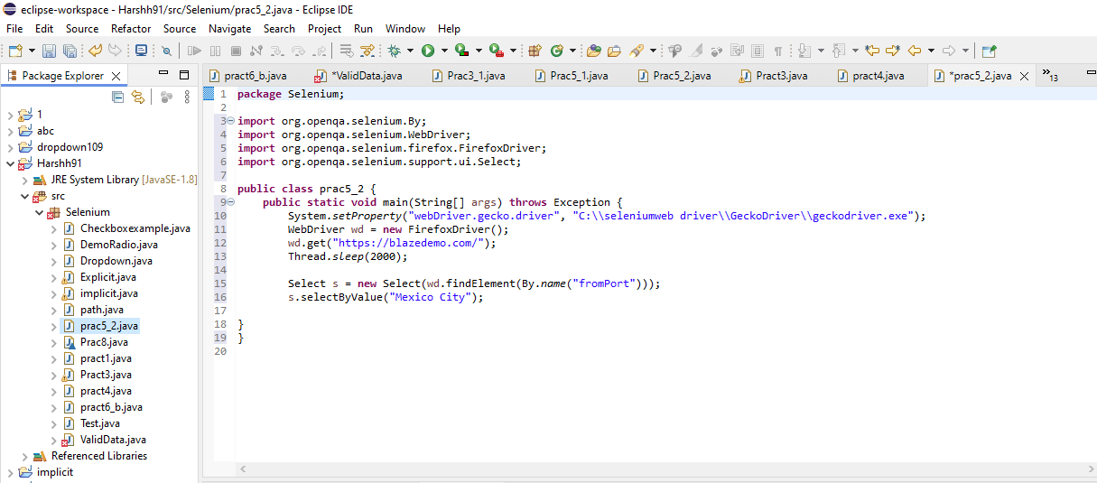

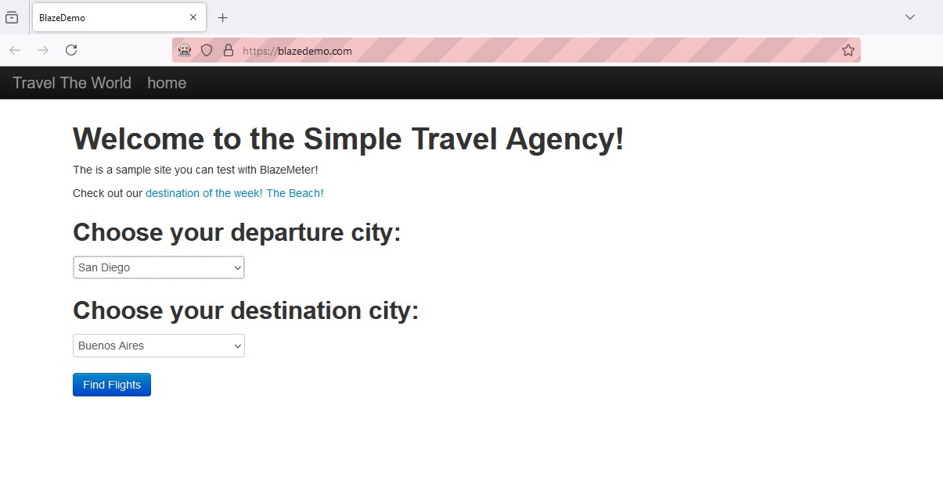

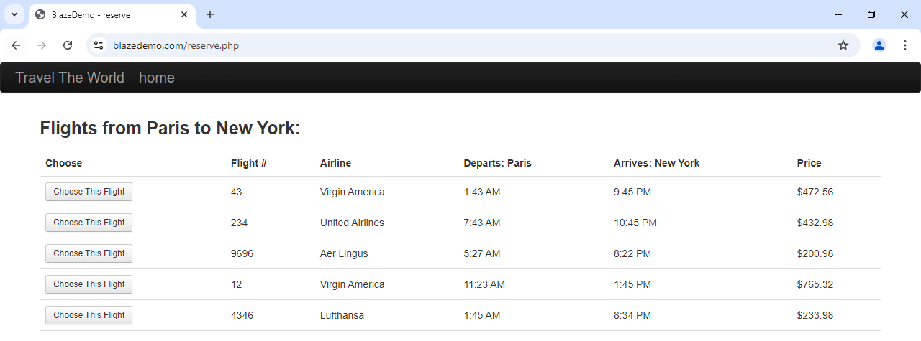

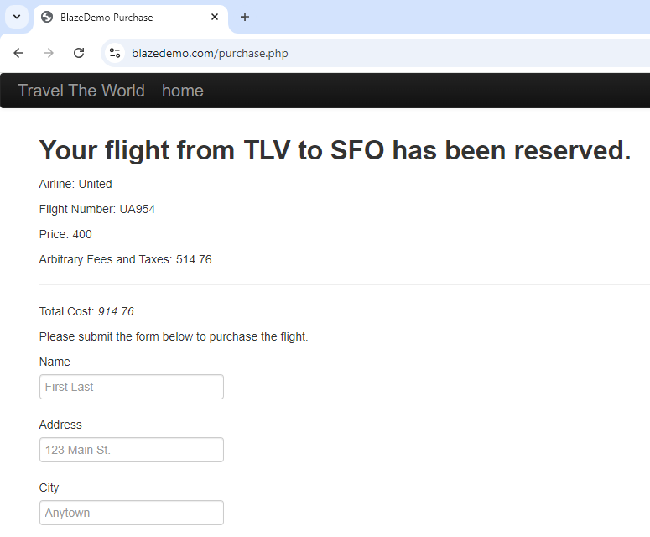

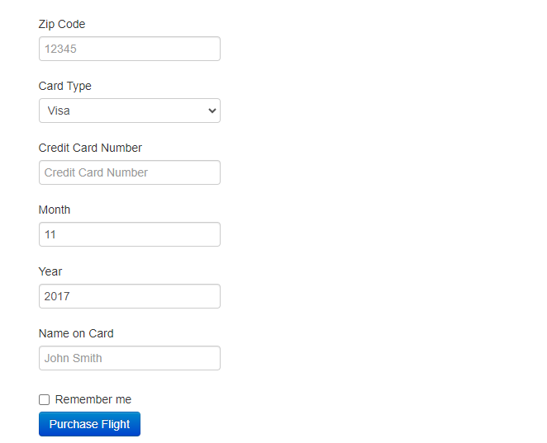

**ByValue**

**Code:**

package Selenium;

import org.openqa.selenium.By;

import org.openqa.selenium.WebDriver;

import org.openqa.selenium.firefox.FirefoxDriver;

import org.openqa.selenium.support.ui.Select;

public class prac5_2 {

public static void main(String[] args) throws Exception {

System.setProperty("webDriver.gecko.driver", "C:\\seleniumweb driver\\GeckoDriver\\geckodriver.exe");

WebDriver wd = new FirefoxDriver();

wd.get("https://blazedemo.com/");

Thread.sleep(2000);

Select s = new Select(wd.findElement(By.name("fromPort")));

s.selectByValue("Mexico City");

}

}



Output:

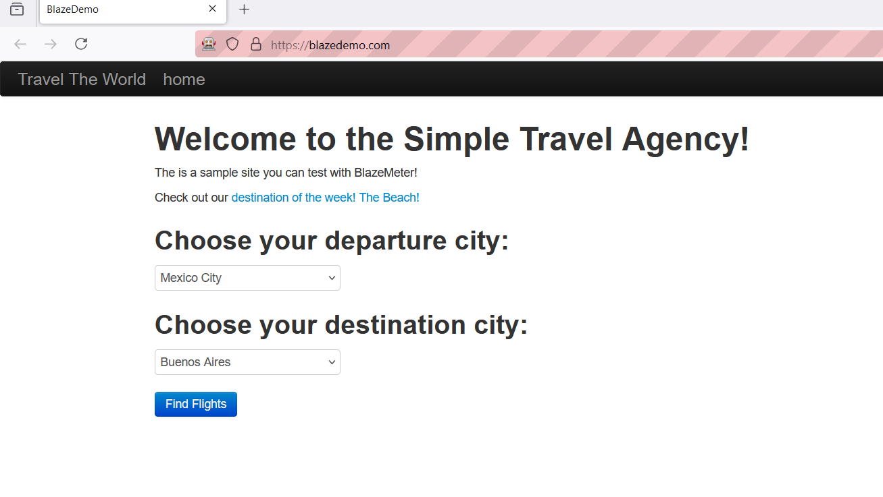

**ByIndex**

Code:

package Selenium;

import org.openqa.selenium.By;

import org.openqa.selenium.WebDriver;

import org.openqa.selenium.firefox.FirefoxDriver;

import org.openqa.selenium.support.ui.Select;

public class prac5 {

public static void main(String[] args) throws Exception {

System.setProperty("webDriver.gecko.driver", "C:\\seleniumweb driver\\GeckoDriver\\geckodriver.exe");

WebDriver wd = new FirefoxDriver();

wd.get("https://blazedemo.com/");

Thread.sleep(2000);

Select s = new Select(wd.findElement(By.name("fromPort")));

//By index

s.selectByIndex(3);

}

}

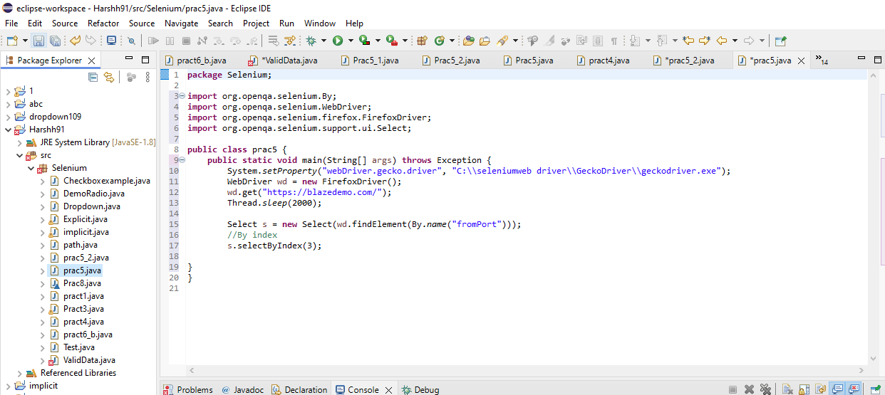

Output:

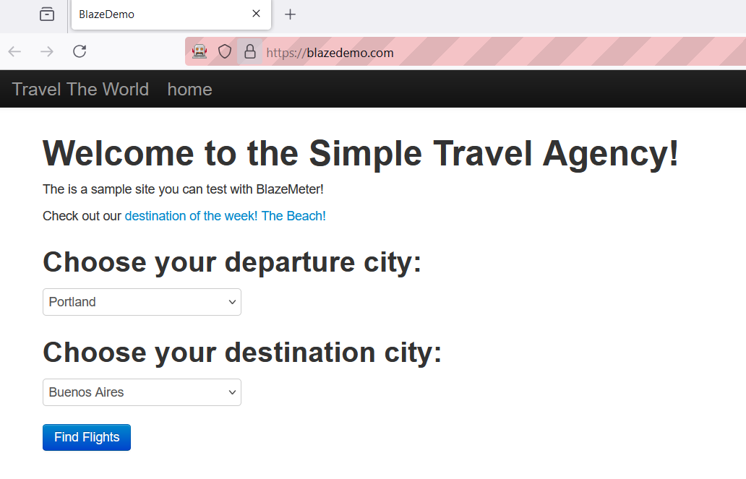

**ListBox**

<!DOCTYPE html>

<html lang="en">

<head>

<meta charset="UTF-8">

<meta http-equiv="X-UA-Compatible" content="IE=edge">

<meta name="viewport" content="width=device-width, initial-scale=1.0">

<title>DropdownList</title>

</head><body>

<h1>Dropdown List </h1>

<h2>Car Company's To WatchOut</h2>

<select id="Cars" name="Cars" size="5" multiple style="font-size: x-large;">

<option value="1">Mercedes</option>

<option value="2">BMW</option>

<option value="3">Audi</option>

<option value="4">Jaguar</option>

<option value="5">Aston Martin</option>

</select></body></html>

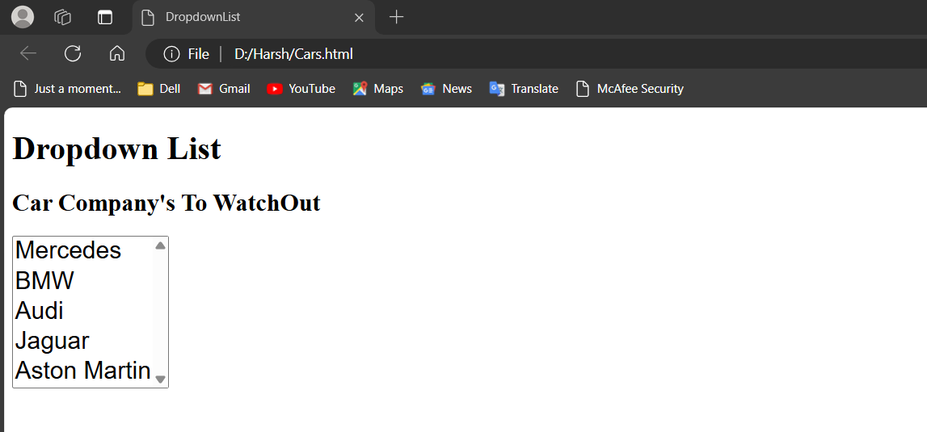

**1)Selecting one value usingIndex**

**Code:**

package prac6;

import org.openqa.selenium.By;

import org.openqa.selenium.WebDriver;

import org.openqa.selenium.firefox.FirefoxDriver;

import org.openqa.selenium.support.ui.Select;

public class Prac6a {

public static void main(String[] args) throws Exception {

System.setProperty("webdriver.chrome.driver","C:\\seleniumweb driver\\GeckoDriver\\geckodriver.exe");

WebDriver wd = new FirefoxDriver();

wd.get("file:///D:/Harsh/Cars.html");

Thread.sleep(2000);

Select s = new Select(wd.findElement(By.id("Cars")));

s.selectByIndex(1);

}

}

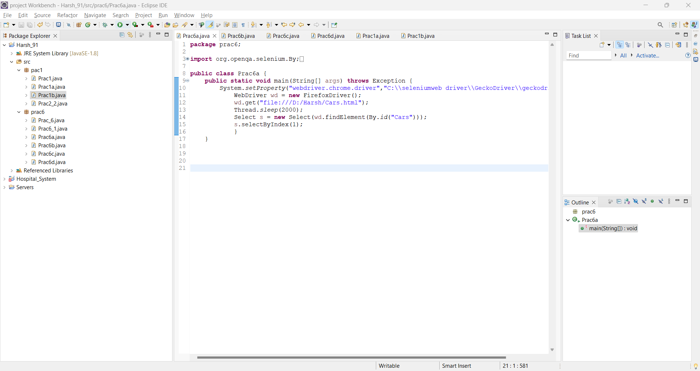

Output:

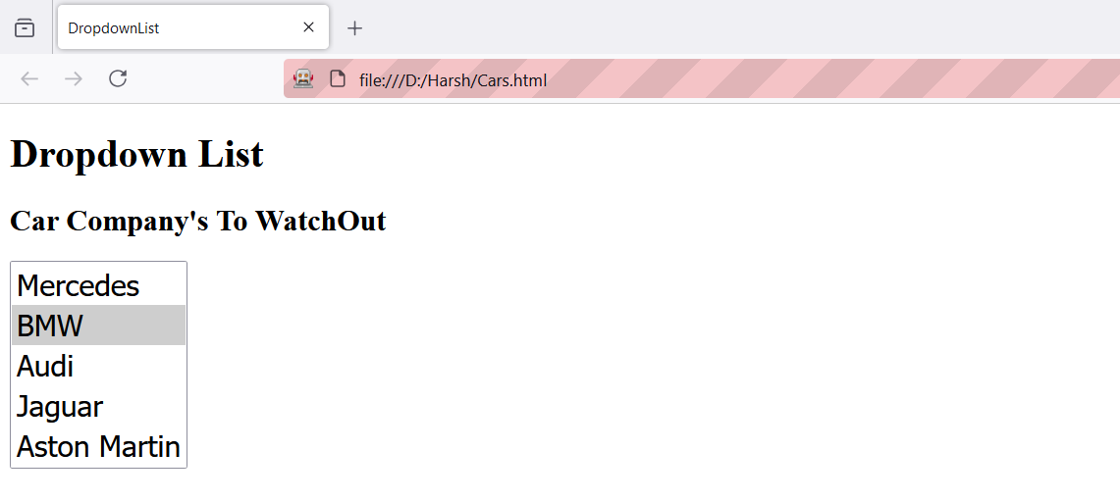

1. **Selecting one value using VisibleText**

**Code:**

package prac6;

import org.openqa.selenium.By;

import org.openqa.selenium.WebDriver;

import org.openqa.selenium.firefox.FirefoxDriver;

import org.openqa.selenium.support.ui.Select;

public class Prac6b {

public static void main(String[] args) throws Exception {

System.setProperty("webdriver.chrome.driver","C:\\seleniumweb driver\\GeckoDriver\\geckodriver.exe");

WebDriver wd = new FirefoxDriver();

wd.get("file:///D:/Harsh/Cars.html");

Thread.sleep(2000);

Select s = new Select(wd.findElement(By.id("Cars")));

s.selectByVisibleText("Audi");}

}

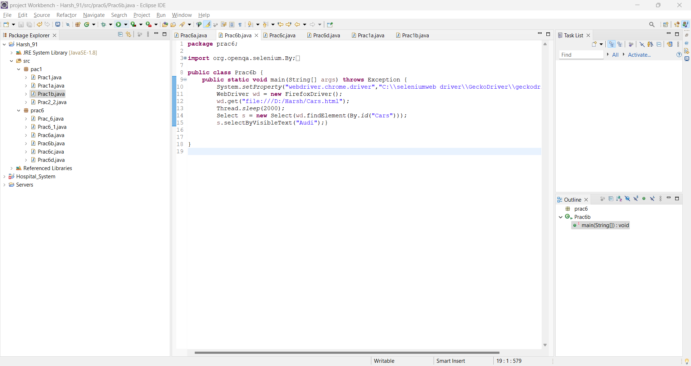

Output:

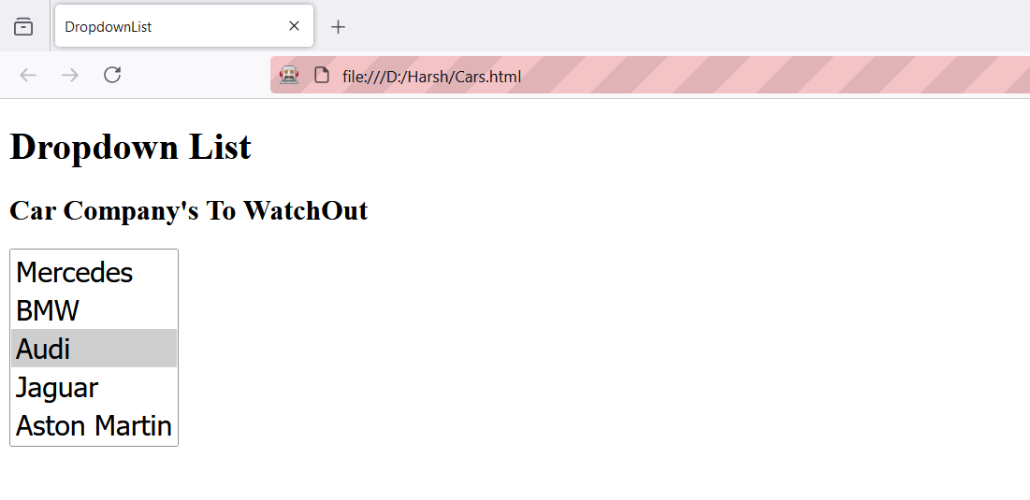

1. **Selecting one value usingValue**

**Code:**

package prac6;

import org.openqa.selenium.By;

import org.openqa.selenium.WebDriver;

import org.openqa.selenium.firefox.FirefoxDriver;

import org.openqa.selenium.support.ui.Select;

public class Prac6c {

public static void main(String[] args) throws Exception {

System.setProperty("webdriver.chrome.driver","C:\\seleniumweb driver\\GeckoDriver\\geckodriver.exe");

WebDriver wd = new FirefoxDriver();

wd.get("file:///D:/Harsh/Cars.html");

Thread.sleep(2000);

Select s = new Select(wd.findElement(By.id("Cars")));

s.selectByValue("5");

}

}

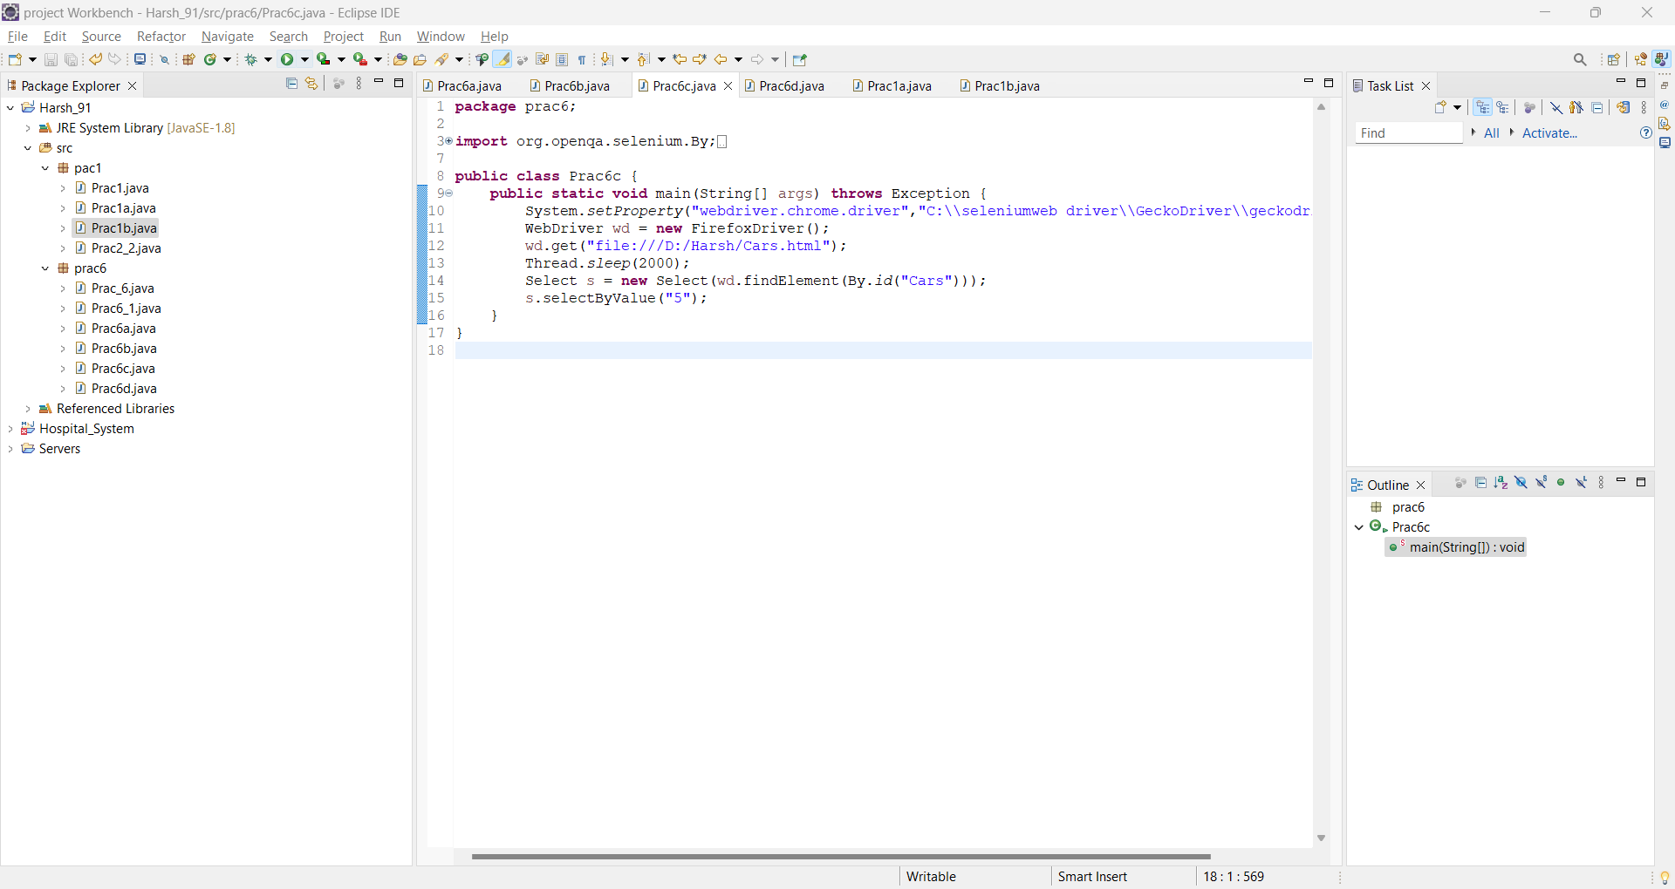

Output:

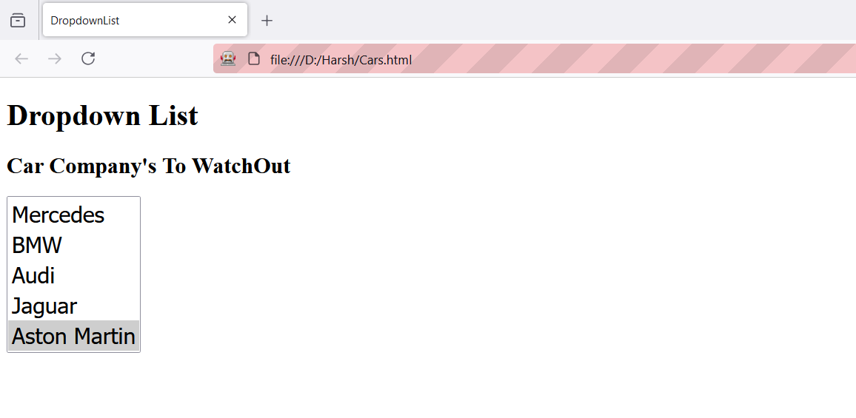

1. **Selecting MultipleValue**

**Code:**

package prac6;

import org.openqa.selenium.By;

import org.openqa.selenium.WebDriver;

import org.openqa.selenium.firefox.FirefoxDriver;

import org.openqa.selenium.support.ui.Select;

public class Prac6d {

public static void main(String[] args) throws Exception {

System.setProperty("webdriver.chrome.driver","C:\\seleniumweb driver\\GeckoDriver\\geckodriver.exe");

WebDriver wd = new FirefoxDriver();

wd.get("file:///D:/Harsh/Cars.html");

Thread.sleep(2000);

Select s = new Select(wd.findElement(By.id("Cars")));

s.selectByIndex(1);

s.selectByVisibleText("Jaguar");

s.selectByValue("5");

}

}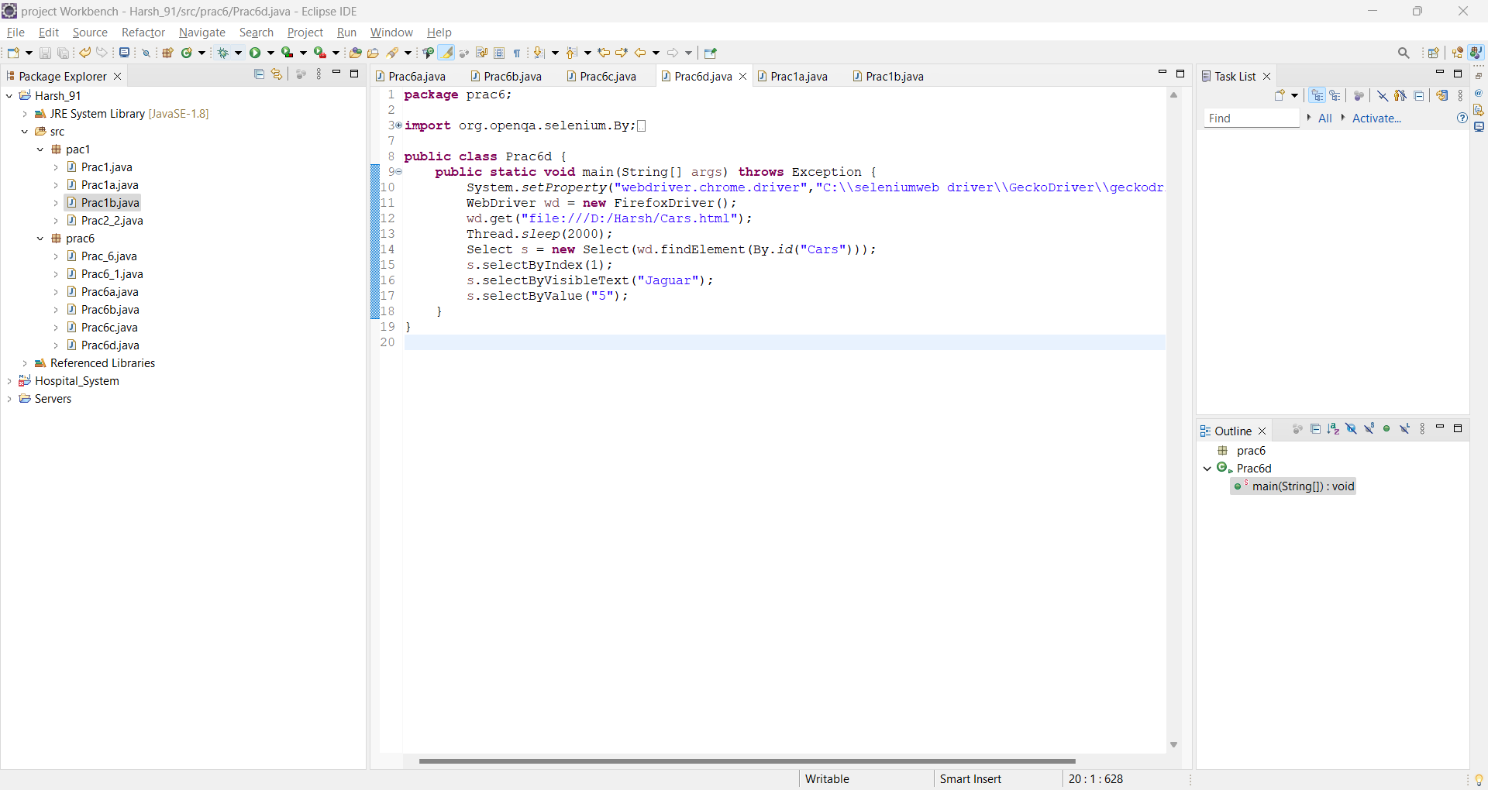

Output:

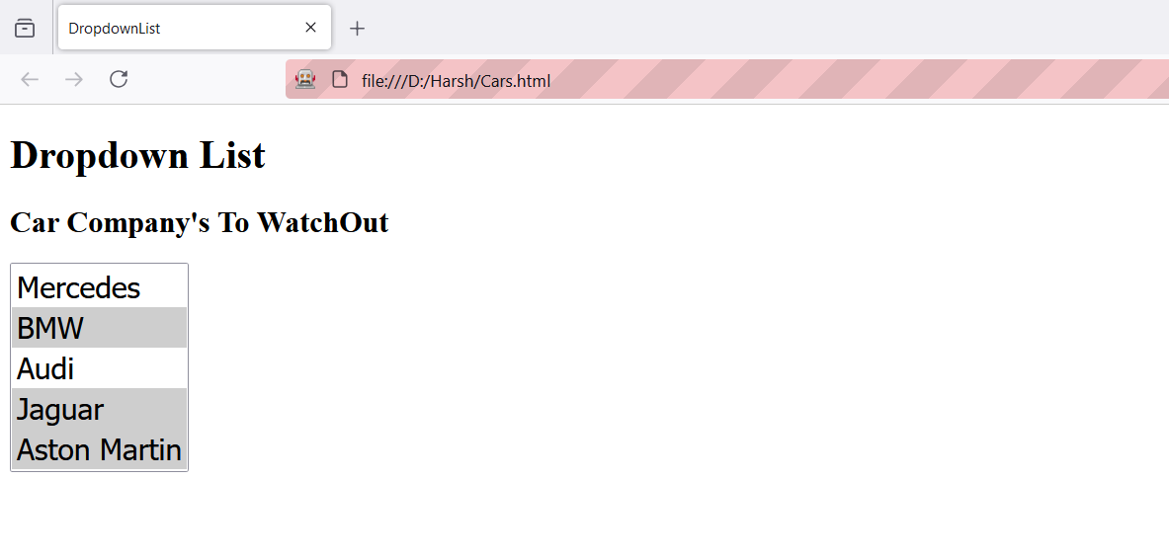

**Practical No: 10**

**Aim: Demonstrate Radio Button and Checkbox.**

**Radiobutton**

Code:

package Selenium;

import org.openqa.selenium.By;

import org.openqa.selenium.WebDriver;

import org.openqa.selenium.chrome.ChromeDriver;

public class DemoRadio

{

public static void main(String[] args)

{

System.setProperty("webdriver.gecko.driver","C:\\selenium web driver\\geckodriver.exe");

WebDriver wd=new ChromeDriver();

wd.get("C:\\Harsh_91\\Radio.html");

wd.findElement(By.xpath("//input[@value='HTML']")).click();

}

}

Html code

<html>

<head>

<body>

<form>

<label for="fname">First Name : </label><br>

<input type="text" id="fname" name="fname"><br>

<label for="=lname">Last Name : </label><br>

<input type="text" id="lname" name="lname">

<br>

<label for="fav_language">Favorite Language</label><br>

<input type="radio" id="html" name="fav_language" value="HTML">

<label for="html">HTML</label><br>

<input type="radio" id="css" name="fav_language" value="CSS">

<label for="css">CSS</label><br>

<input type="radio" id="javascript" name="fav_language" value="JavaScript">

<label for="javascript">JavaScript</label>

</form>

</body>

</html>

Output:

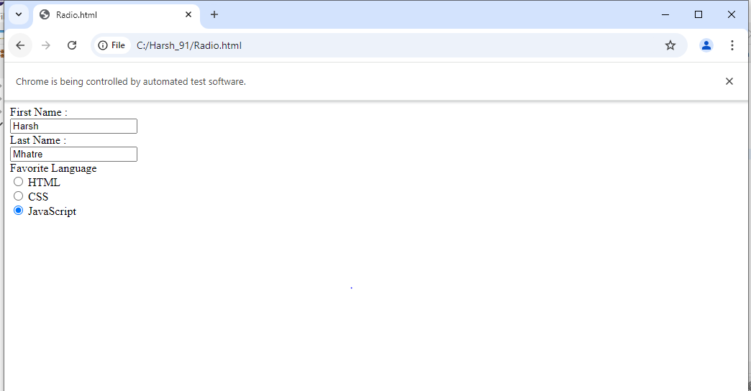

**Checkbox**

Code:

package Selenium;

import org.openqa.selenium.By;

import org.openqa.selenium.WebDriver;

import org.openqa.selenium.WebElement;

import org.openqa.selenium.chrome.ChromeDriver;

public class Checkboxexample

{

public static void main(String[] args)

{

System.setProperty("webdriver.chrome.driver","E:\\chromedriver-win64\\chromedriver.exe");

WebDriver driver=new ChromeDriver();

driver.get("C:\\Harsh_91\\Checkbox.html");

WebElement checkbox1=driver.findElement(By.id("checkbox1"));

checkbox1.click();

WebElement checkbox2=driver.findElement(By.xpath("//input[@value='HTML']"));

checkbox2.click();

WebElement checkbox3=driver.findElement(By.xpath("//label[contains(text(),'Option3']/input"));

checkbox3.click();

try

{

Thread.sleep(2000);

}

catch(InterruptedException e)

{

e.printStackTrace();

}

driver.quit();

}

}

**Checkbox.html**

<!DOCTYPE html>

<html><head>

<title>Checkbox Example</title>

</head><body>

<h2>Checkbox Example</h2>

<form id="checkboxForm">

<label><input type="checkbox" id="checkbox1" value="option1">C</label><br>

<label><input type="checkbox" id="checkbox2" value="option1">C++</label><br>

<label><input type="checkbox" id="checkbox3" value="option1">Java</label><br>

<button type="button" onClick="submitForm()">Submit</button>

</form><script>

function submitForm(){

document.getElementById("checkboxForm").submit();}

</script></body></html>

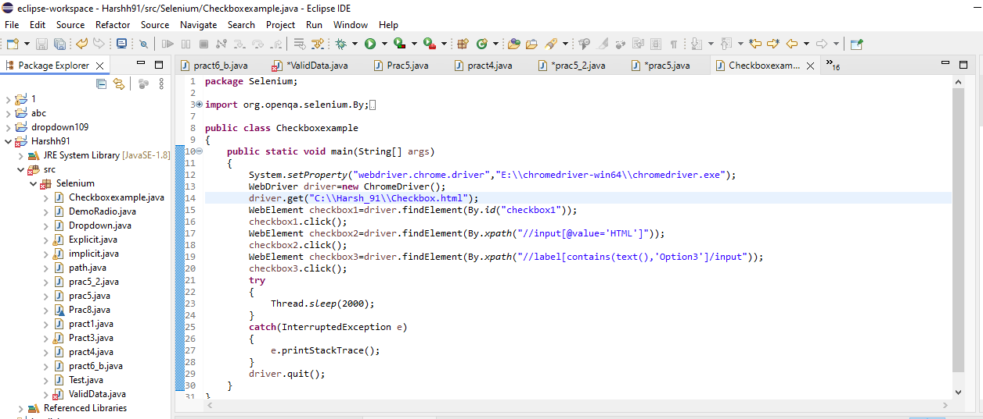

Output:

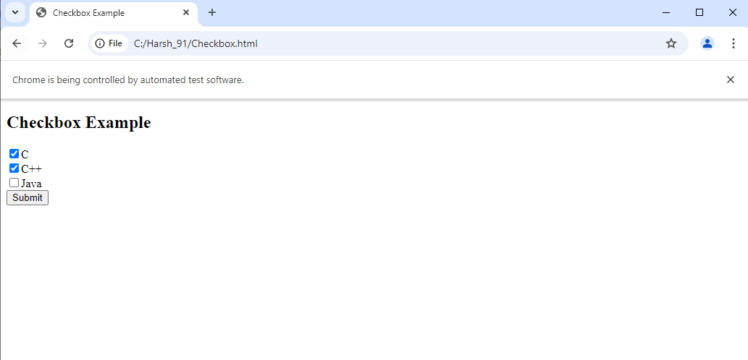

**Practical No: 11**

**Aim: Demonstrate action classes in Selenium.**

**Code:**

**package** prac11;

**import** java.util.List;

**import** org.openqa.selenium.By;

**import** org.openqa.selenium.WebDriver;

**import** org.openqa.selenium.WebElement;

**import** org.openqa.selenium.firefox.FirefoxDriver;

**import** org.openqa.selenium.interactions.Actions;

**public** **class** Prac11 {

**public** **static** **void** main(String[] args) **throws** InterruptedException

{

System.*setProperty*("webDriver.gecko.driver", "C:\\\\selenium web driver\\\\firefox driver\\\\geckodriver.exe");

WebDriver wd = **new** FirefoxDriver();

wd.get("https://www.saucedemo.com/v1/");

Thread.*sleep*(3000);

wd.findElement(By.*name*("user-name")).sendKeys("standard_user");

wd.findElement(By.*name*("password")).sendKeys("secret_sauce");

wd.findElement(By.*id*("login-button")).click();

Thread.*sleep*(3000);

wd.findElement(By.*className*("bm-burger-button")).click();

Actions act = **new** Actions(wd);

Thread.*sleep*(3000);

List<WebElement> menu = wd.findElements(By.*className*("bm-item-list"));

**for**(**int** i=0; i<=menu.size()-1; i++)

{

System.***out***.println(menu.get(i).getText());

act.moveToElement(menu.get(i)).perform();

}

}

}

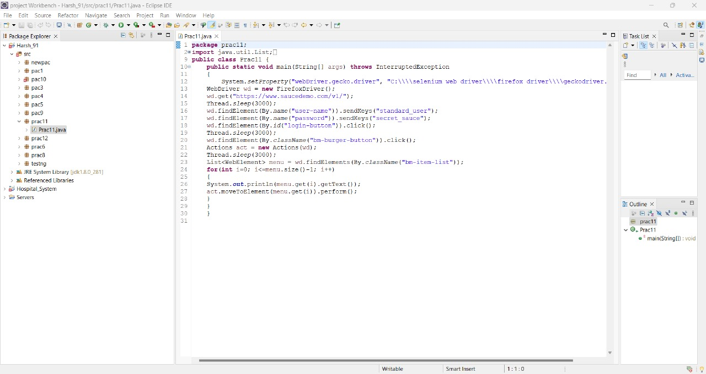

**Output:**

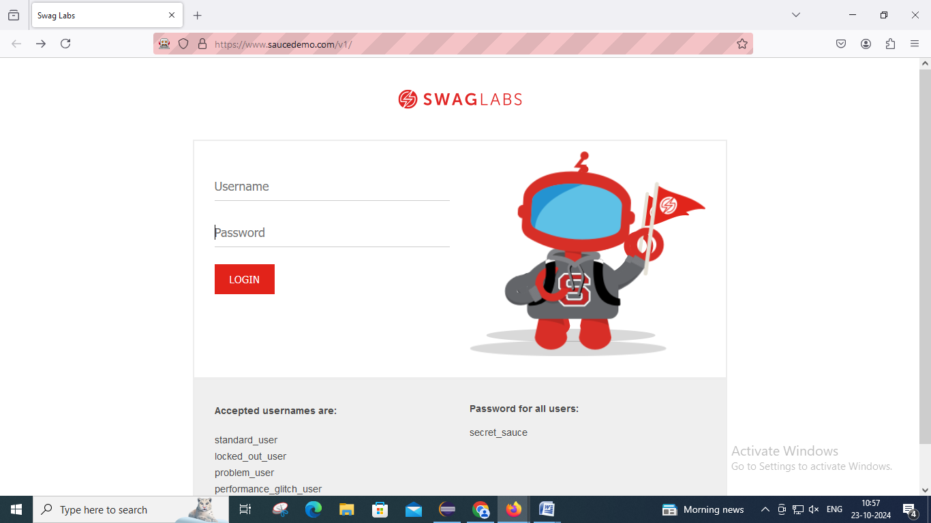

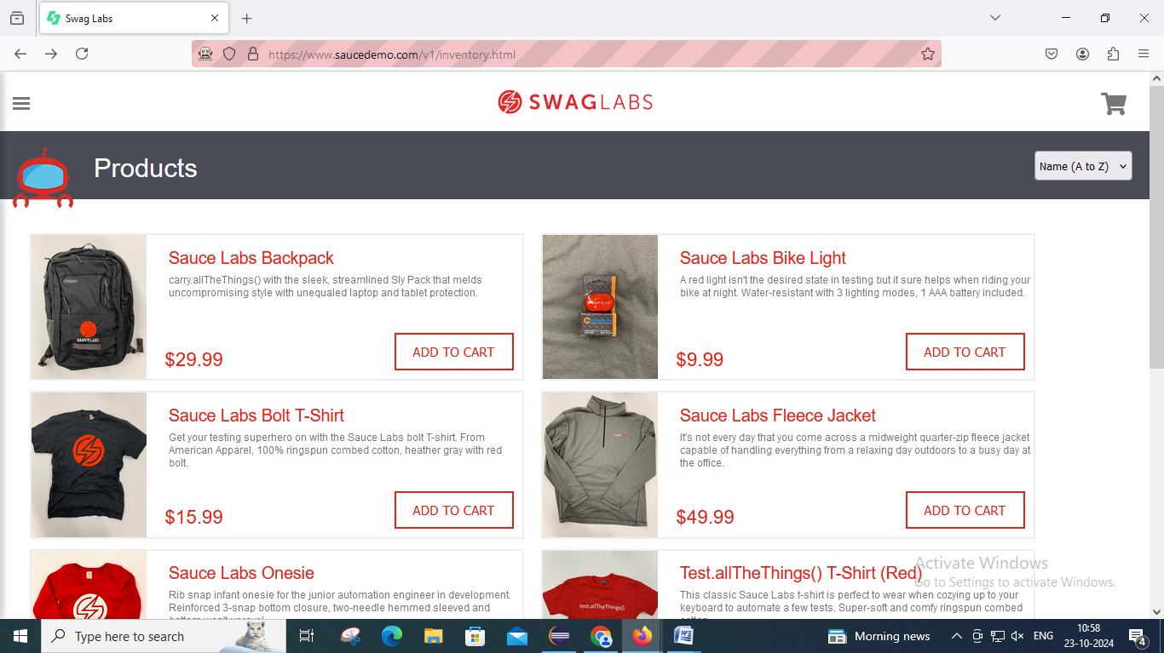

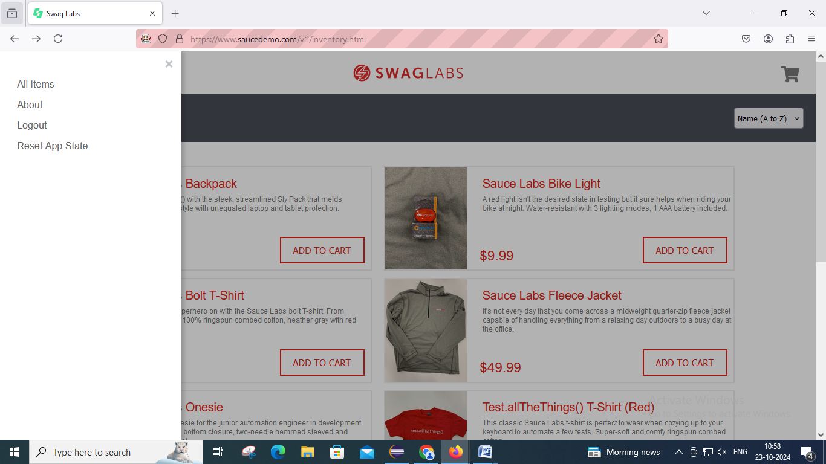

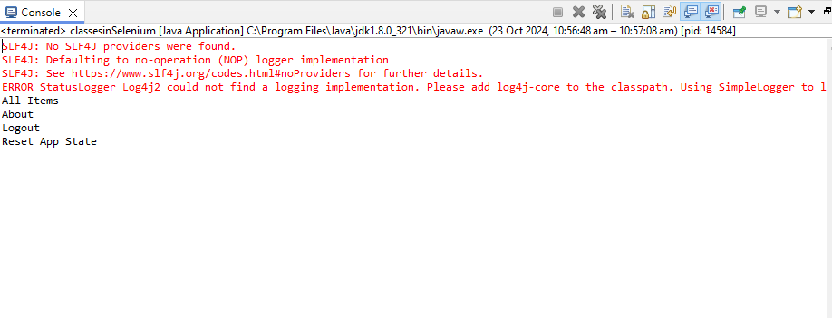

**Practical No: 12**

**Aim: Installation of TestNg, running TestNg & TestNg annotations.**

**Installation:**

Click on Help > Eclipse Marketplace

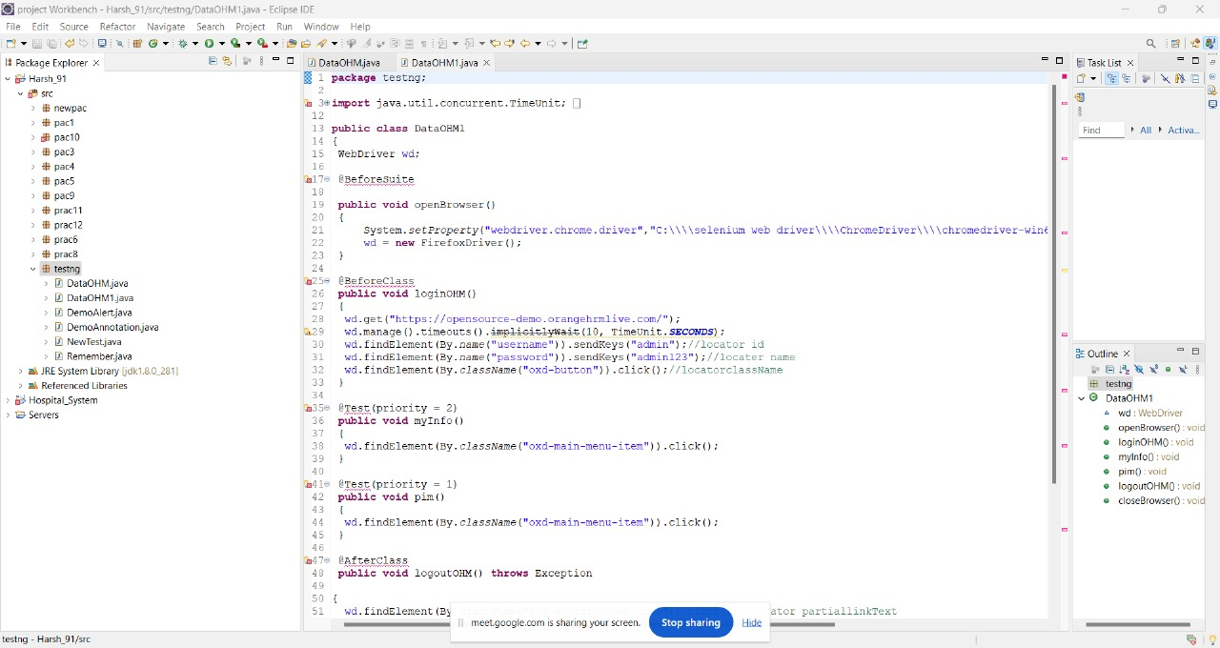

Then Type testNg and press Go

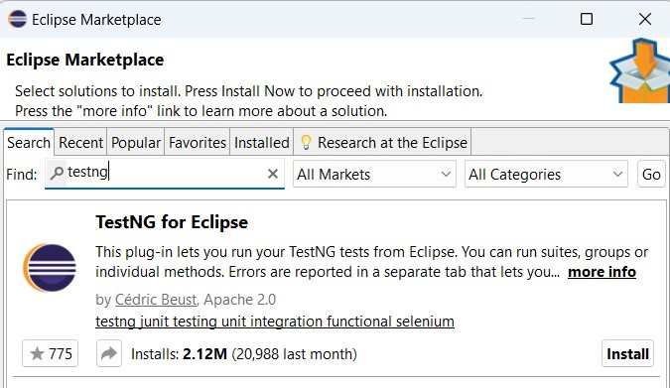

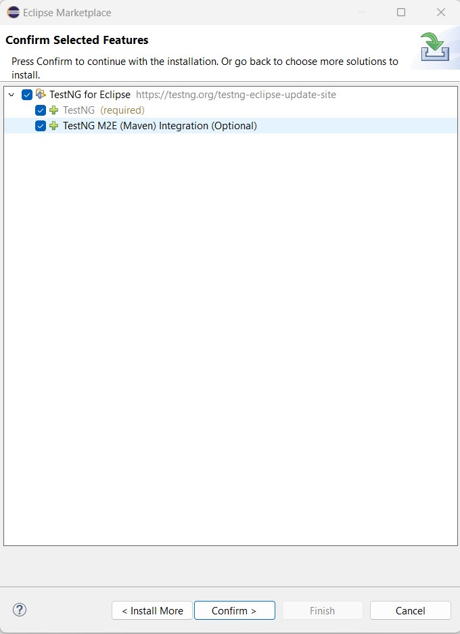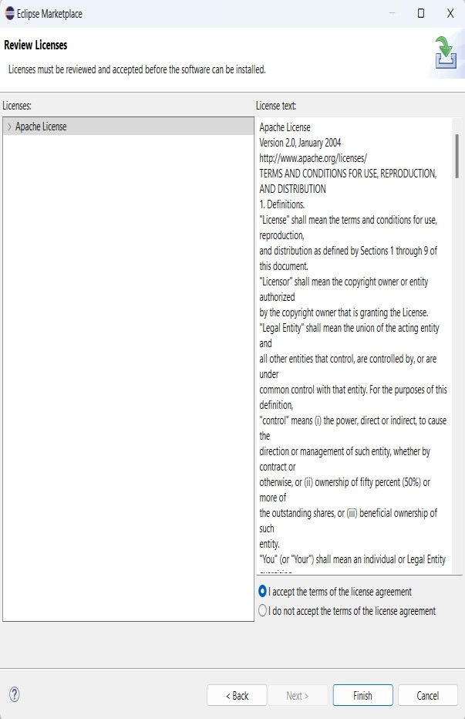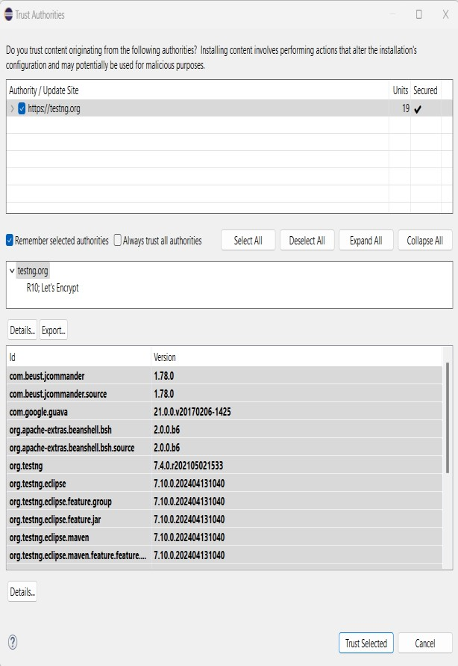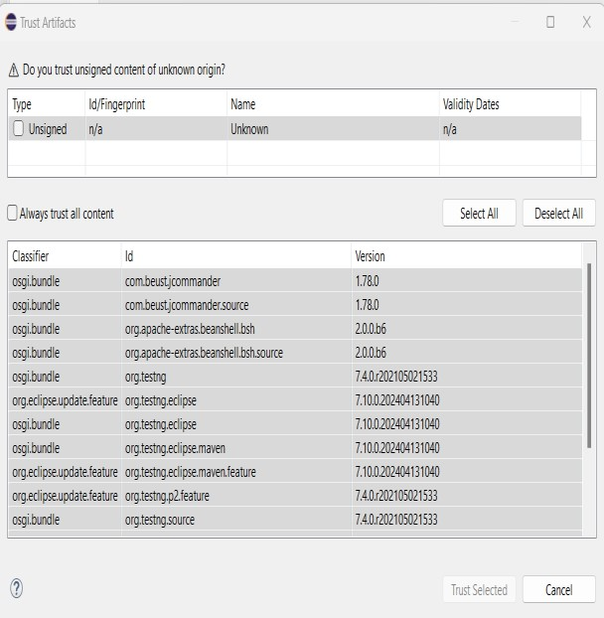

Right-Click on Project an click on Build Path then click on “Configure Build Path”

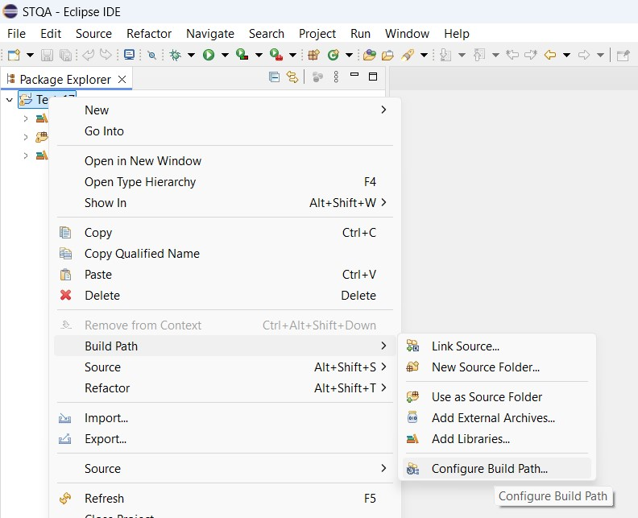

Click on Add Library

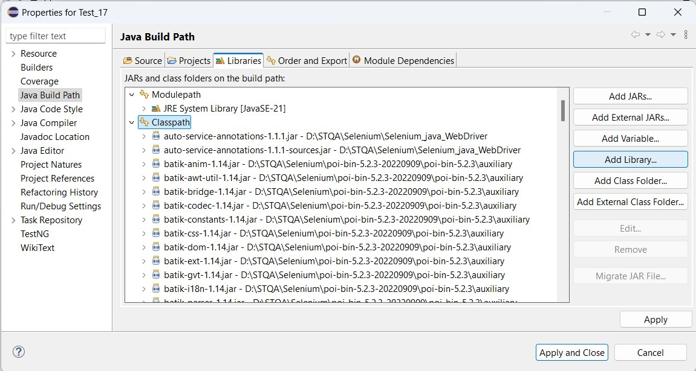

Click on TestNg then Click on Next

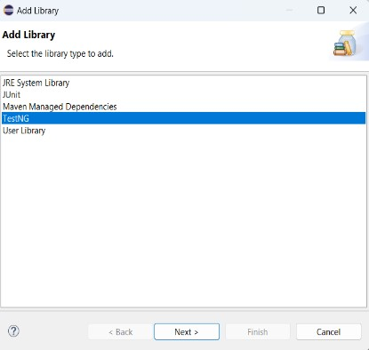

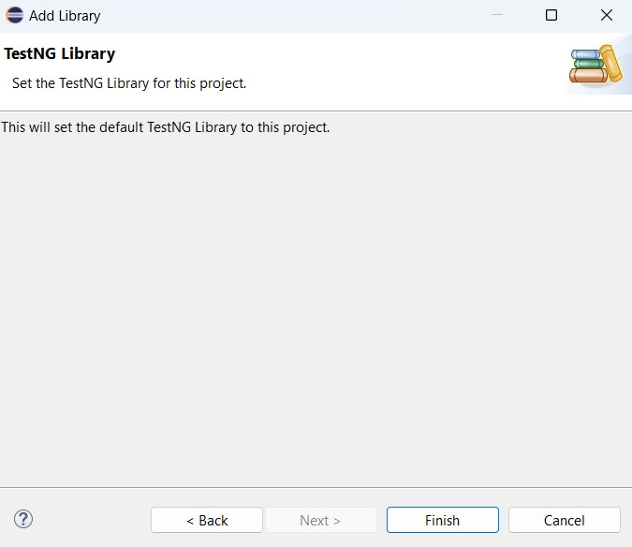

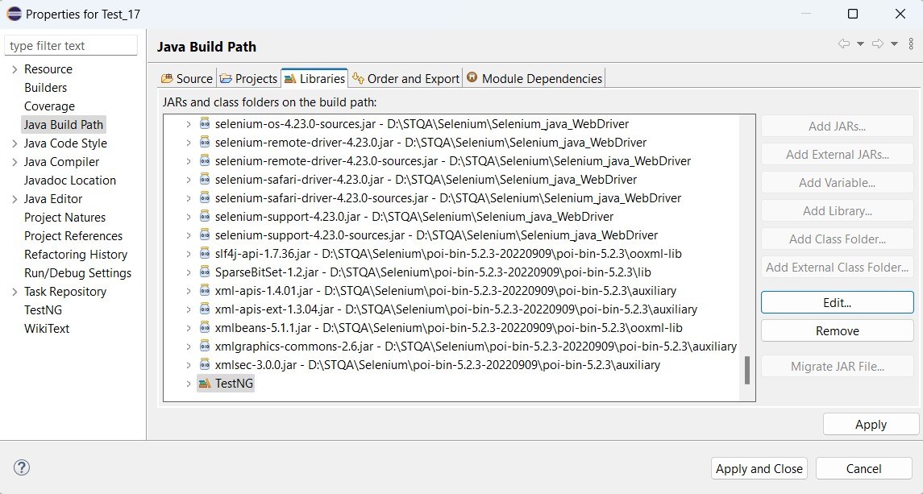

**A) DemoDataProvider**

**Code:**

package testng;

import org.testng.annotations.Test;

import org.testng.annotations.DataProvider;

public class NewTest {

@Test(dataProvider = "dp")

public void f(Integer n, String s) {

System.out.println(n + " " + s);

}

@DataProvider

public Object[][] dp() {

return new Object[][] {

new Object[] { 1, "a" },

new Object[] { 2, "b" },

new Object[] { 3, "c" },

new Object[] { 4, "Harsh Mhatre"},

};

}

}

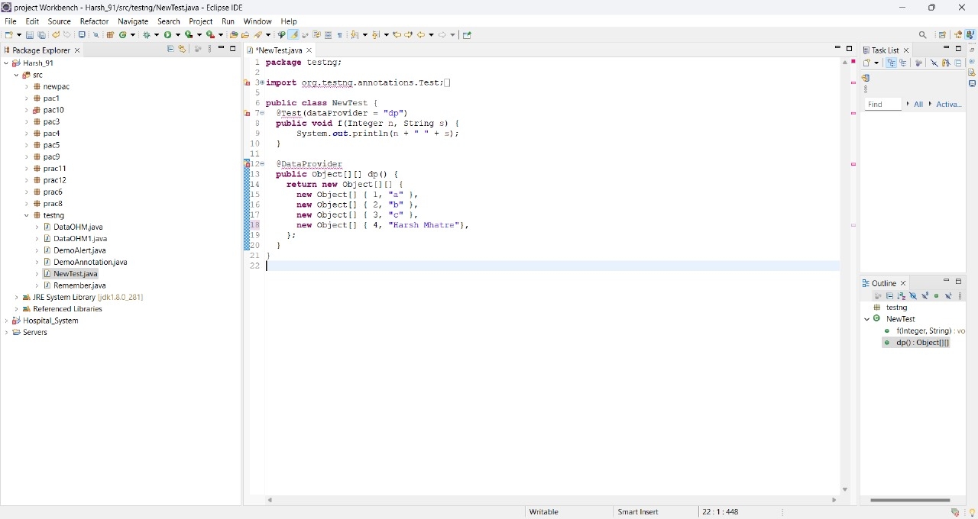

**Output:**

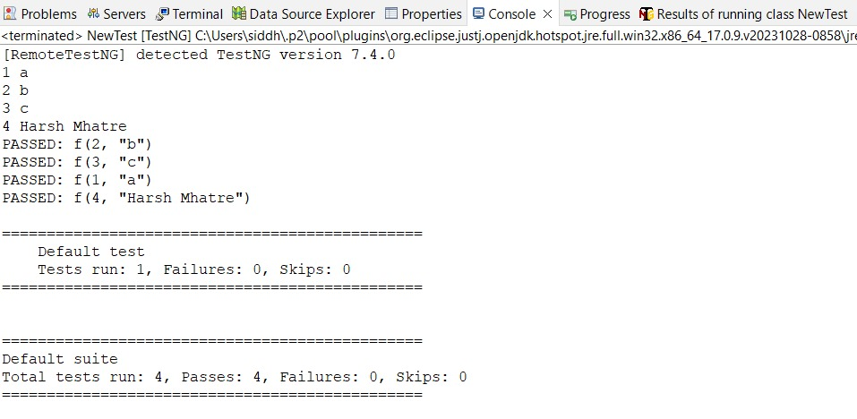

**B) Demo Annotation**

**Code:**

package testng;

import org.testng.annotations.Test;

import org.testng.annotations.BeforeMethod;

import org.testng.annotations.AfterMethod;

import org.testng.annotations.BeforeClass;

import org.testng.annotations.AfterClass;

import org.testng.annotations.BeforeTest;

import org.testng.annotations.AfterTest;

import org.testng.annotations.BeforeSuite;

import org.testng.annotations.AfterSuite;

public class DemoAnnotation {

@Test

public void f() {

System.out.println("Roll no: 63");

}

@BeforeMethod

public void beforeMethod() {

System.out.println("Before Method");

}

@AfterMethod

public void afterMethod() {

System.out.println("After Method");

}

@BeforeClass

public void beforeClass() {

System.out.println("Before Class");

}

@AfterClass

public void afterClass() {

System.out.println("After Class");

}

@BeforeTest

public void beforeTest() {

System.out.println("Before Test");

}

@AfterTest

public void afterTest() {

System.out.println("After Test");

}

@BeforeSuite

public void beforeSuite() {

System.out.println("Before Suite");

}

@AfterSuite

public void afterSuite() {

System.out.println("After Suite");

}

}

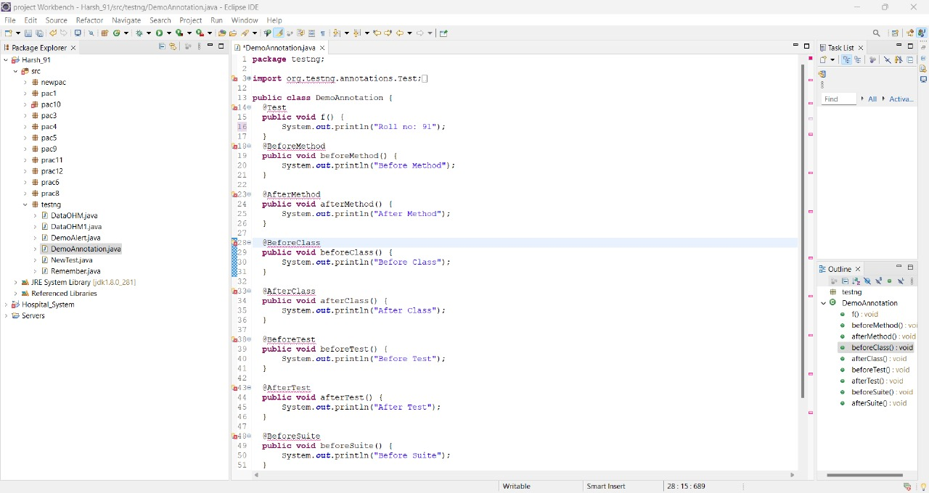

**Output:**

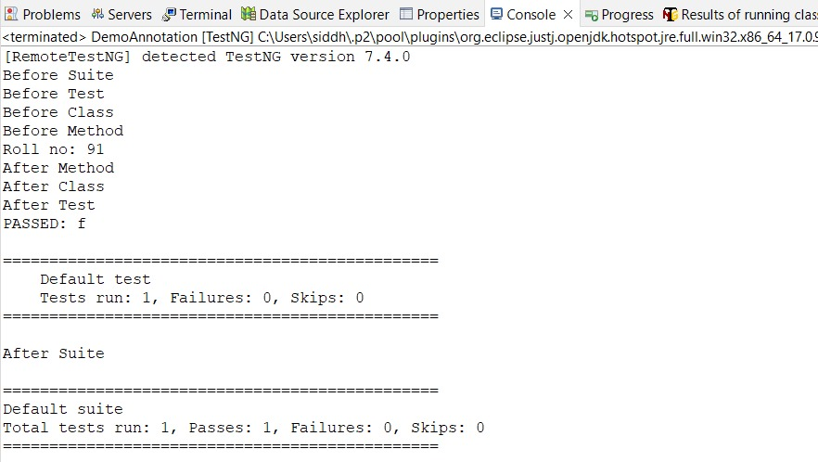

**C) DataOHM**

**Code:**

package testng;

import org.testng.annotations.Test;

import java.util.concurrent.TimeUnit;

import org.openqa.selenium.By;

import org.openqa.selenium.WebDriver;

import org.openqa.selenium.firefox.FirefoxDriver;

import org.testng.annotations.DataProvider;

public class DataOHM {

@Test(dataProvider = "dp")

public void f(String u, String p) {

System.setProperty("webDriver.gecko.driver", "D:\\software_st\\geckodriver.exe");

WebDriver wd = new FirefoxDriver();

wd.get("https://opensource-demo.orangehrmlive.com/");

wd.manage().timeouts().implicitlyWait(10,TimeUnit.SECONDS);

wd.findElement(By.name("username")).sendKeys("u"); //locator id

wd.findElement(By.name("password")).sendKeys("p"); //locator name

wd.findElement(By.className("oxd-button oxd-button--medium oxd-button--main orangehrm-login-button")).click(); //locator classname

try {

wd.findElement(By.className("oxd-userdropdown-name")).click();

wd.findElement(By.className("oxd-userdropdown-link")).click();

System.out.println("Pass");

}catch(Exception e) {

System.out.println("Fail");

}}

@DataProvider

public Object[][] dp() {

return new Object[][] {

new Object[] { "Admin", "admin123" },

new Object[] { "add", "b" },

};

}

}

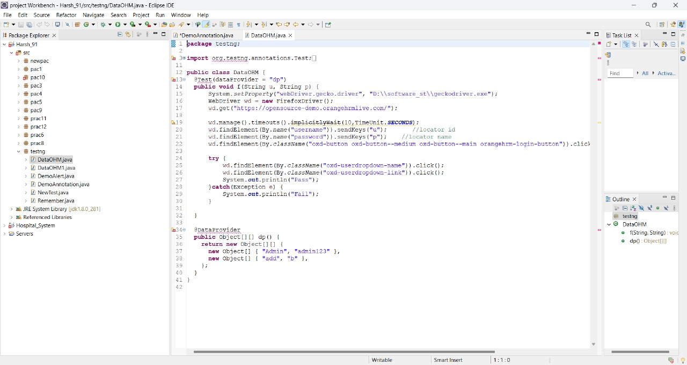

**Output:**

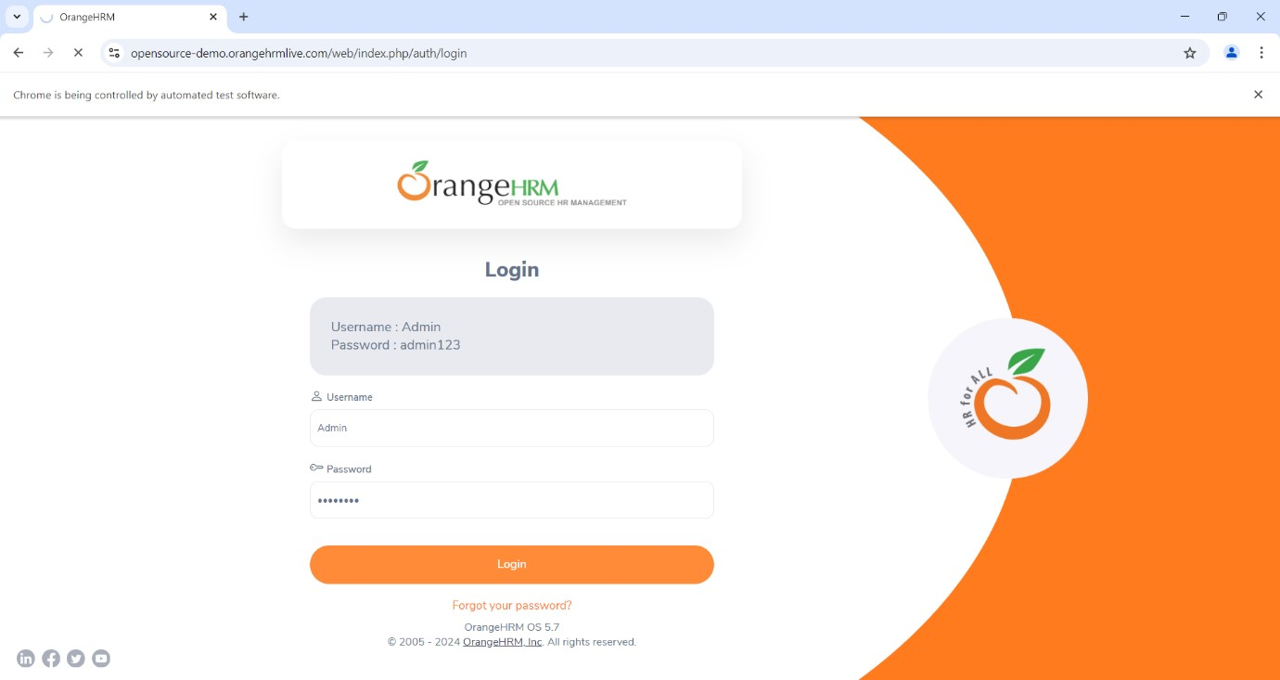

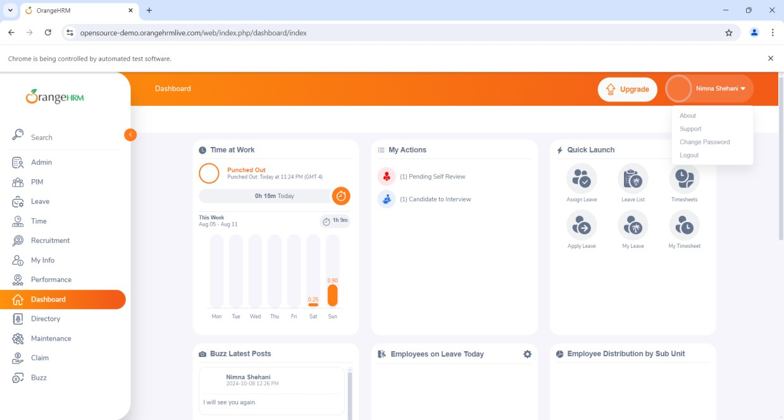

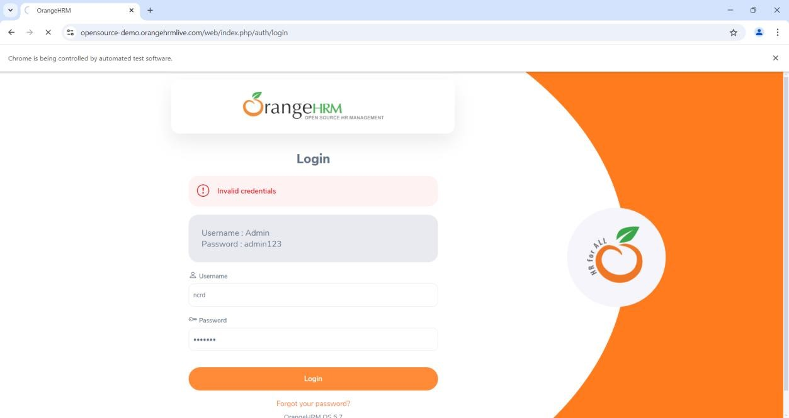

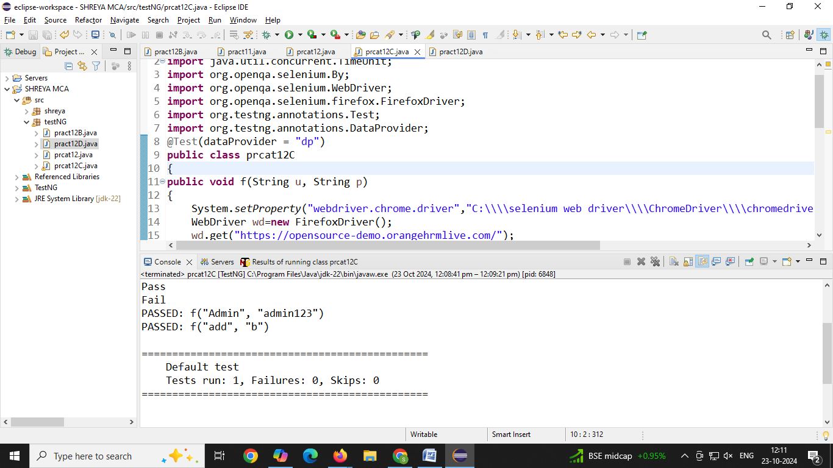

**D) DataCheck**

**Code:**

**package** testng;

**import** org.openqa.selenium.By;

**import** org.openqa.selenium.WebDriver;

**import** org.openqa.selenium.chrome.ChromeDriver;

**import** org.testng.Assert;

**import** org.testng.annotations.Test;

**public** **class** Remember {

@Test(description="Checking status of checkbox")

**public** **void** CheckBox()

{

System.*setProperty*("webdriver.chrome.driver", "D:\\Selenium\\chromedriver-win64\\chromedriver.exe");

WebDriver wd = **new** ChromeDriver();

wd.get("https://mail.rediff.com/cgi-bin/login.cgi");

**boolean** sts = wd.findElement(By.*name*("Remeber")).isSelected();

Assert.*assertTrue*(sts);

}

}

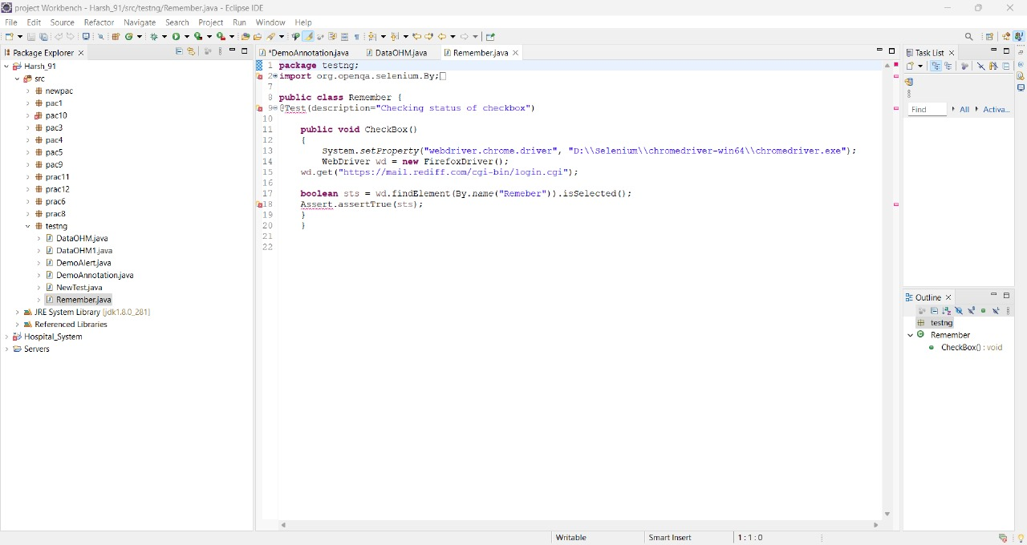

**Output:**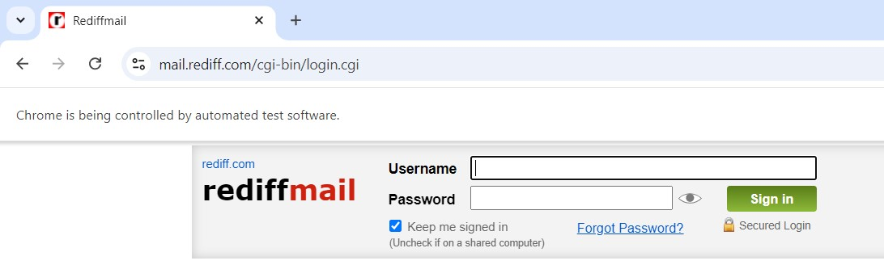

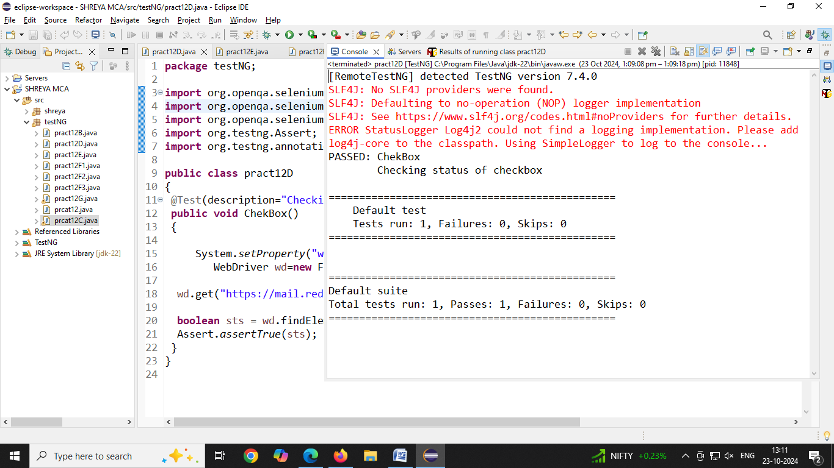

**E) DemoAssertFA**

**Code:**

**package** prac12;

**import** org.openqa.selenium.WebDriver;

**import** org.openqa.selenium.firefox.FirefoxDriver;

**import** org.testng.Assert;

**import** org.testng.annotations.Test;

**public** **class** frontAccounting {

@Test

**public** **void** frontAccounting()

{

System.*setProperty*("webdriver.chrome.driver", "D:\\Selenium\\chromedriver-win64\\chromedriver.exe");

WebDriver wd = **new** FirefoxDriver();

wd.get("https://demo.frontAccounting.eu/index.php");

String expectedTitle = "FrontAccounting 2.4.12 - Login";

String actualTitle =wd.getTitle();

Assert.*assertEquals*(actualTitle, expectedTitle);

System.***out***.println("Title of Webpage ======>"+actualTitle);

}

}

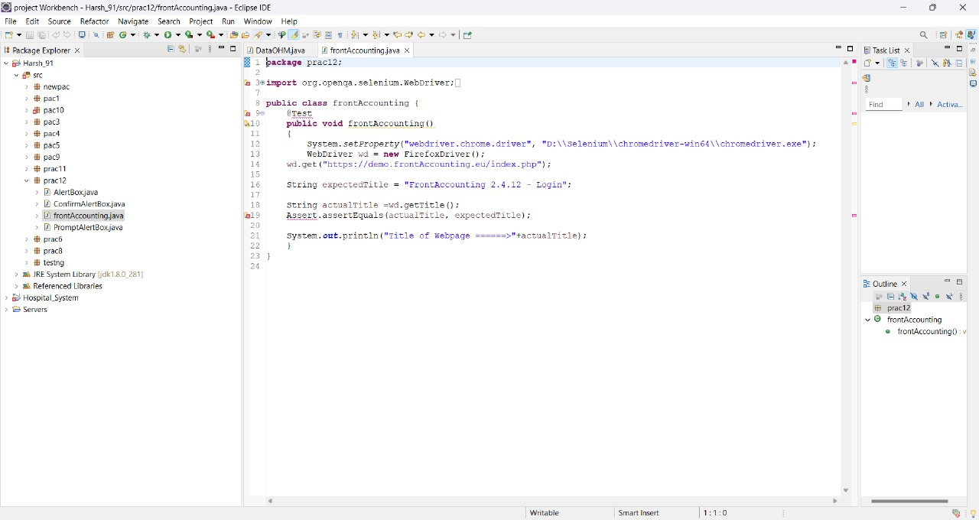

**Output:**

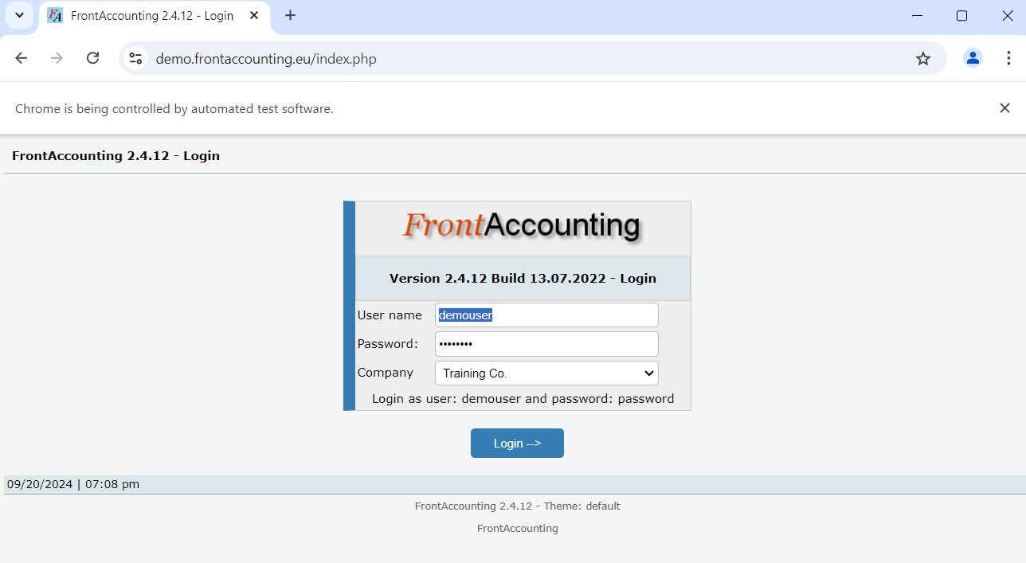

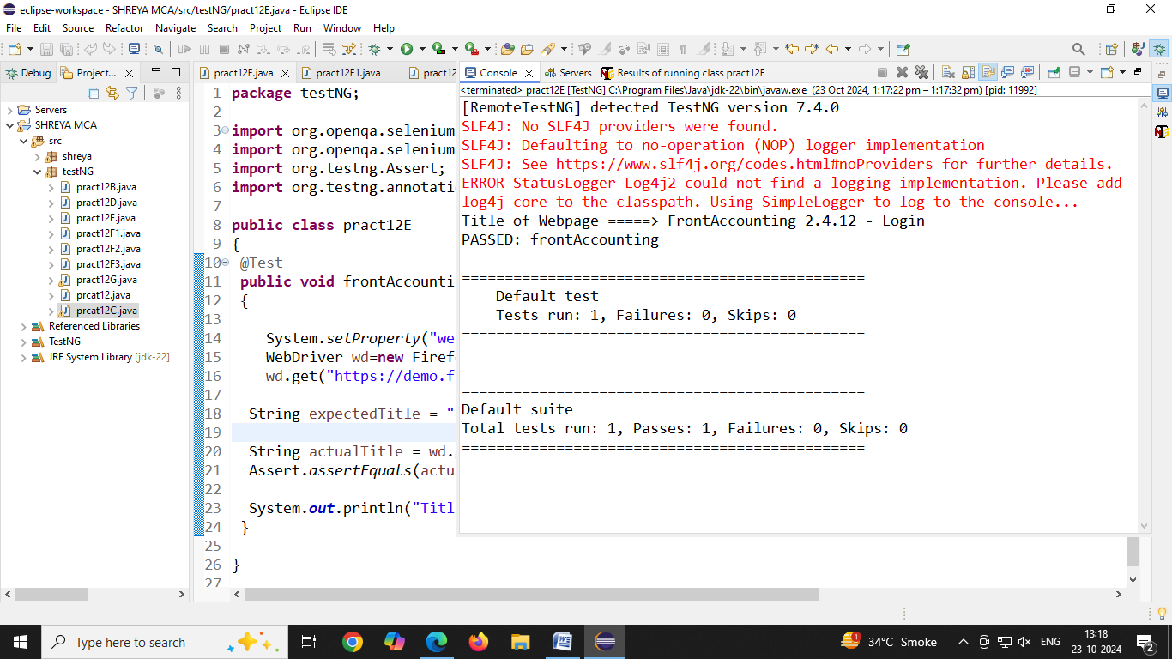

**F) DemoAlert :**

**1] Alertbox**

**Code:**

**package** prac12;

**import** org.openqa.selenium.Alert;

**import** org.openqa.selenium.By;

**import** org.openqa.selenium.WebDriver;

**import** org.openqa.selenium.firefox.FirefoxDriver;

**public** **class** AlertBox {

**public** **static** **void** main(String[] args) **throws** Exception

{

System.*setProperty*("webDriver.gecko.driver", "C:\\selenium webdriver\\GeckoDriver\\geckodriver.exe");

WebDriver wd = **new** FirefoxDriver();

wd.get("https://vinothqaacademy.com/alert-and-popup/");

wd.findElement(By.*name*("alertbox")).click();

Thread.*sleep*(2000);

Alert alt = wd.switchTo().alert();

System.***out***.println(" Harsh Text of Alert " + alt.getText());//capture text

alt.accept();//click on OK button

}

}

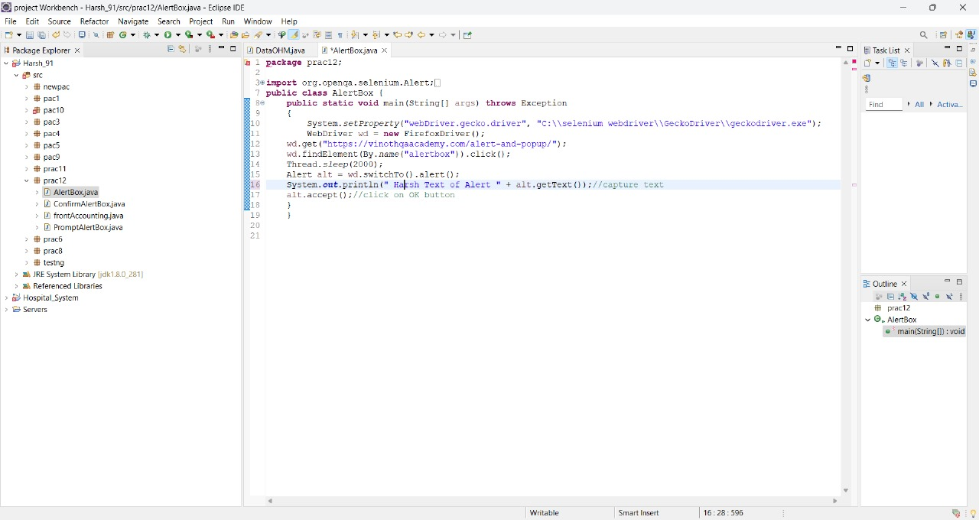

**Output:**

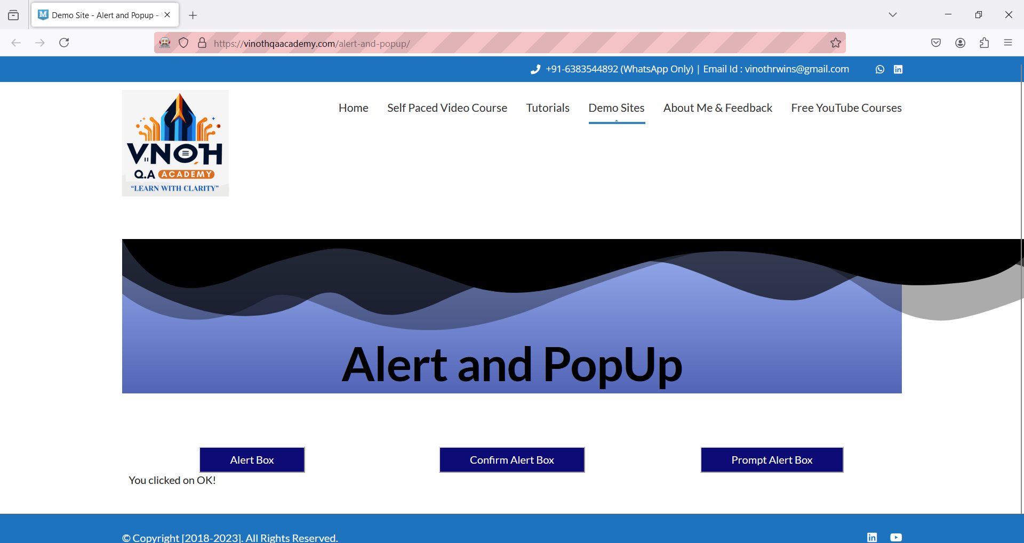

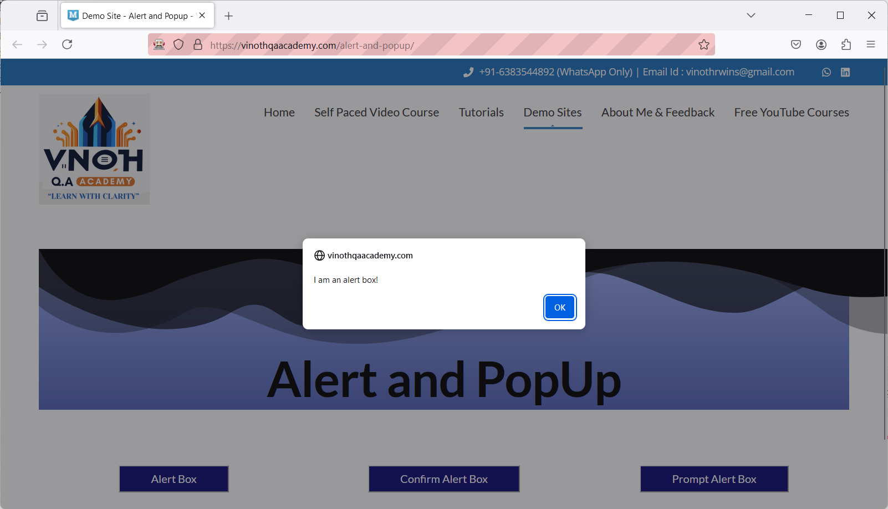

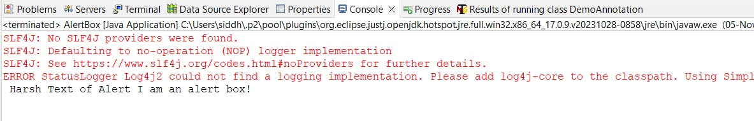

**2] Confirm Alertbox**

**Code:**

**package** prac12;

**import** org.openqa.selenium.Alert;

**import** org.openqa.selenium.By;

**import** org.openqa.selenium.WebDriver;

**import** org.openqa.selenium.firefox.FirefoxDriver;

**public** **class** ConfirmAlertBox {

**public** **static** **void** main(String[] args) **throws** Exception

{

System.*setProperty*("webDriver.gecko.driver", "C:\\selenium webdriver\\GeckoDriver\\geckodriver.exe");

WebDriver wd = **new** FirefoxDriver();

wd.get("https://vinothqaacademy.com/alert-and-popup/");

wd.findElement(By.*name*("ConfirmAlertBox")).click();

Thread.*sleep*(2000);

Alert alt = wd.switchTo().alert();

System.***out***.println("Text of Alert " + alt.getText());//capture text

alt.accept();//click on OK button

}

}

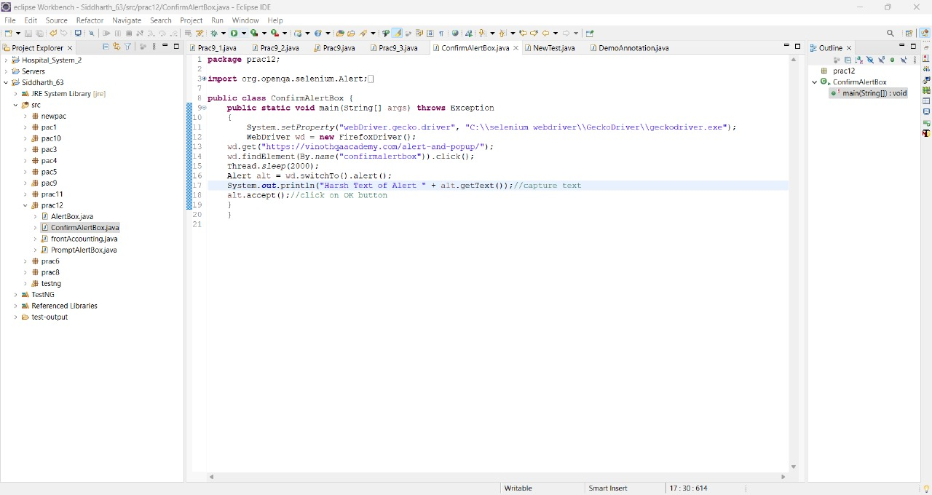

**Output:**

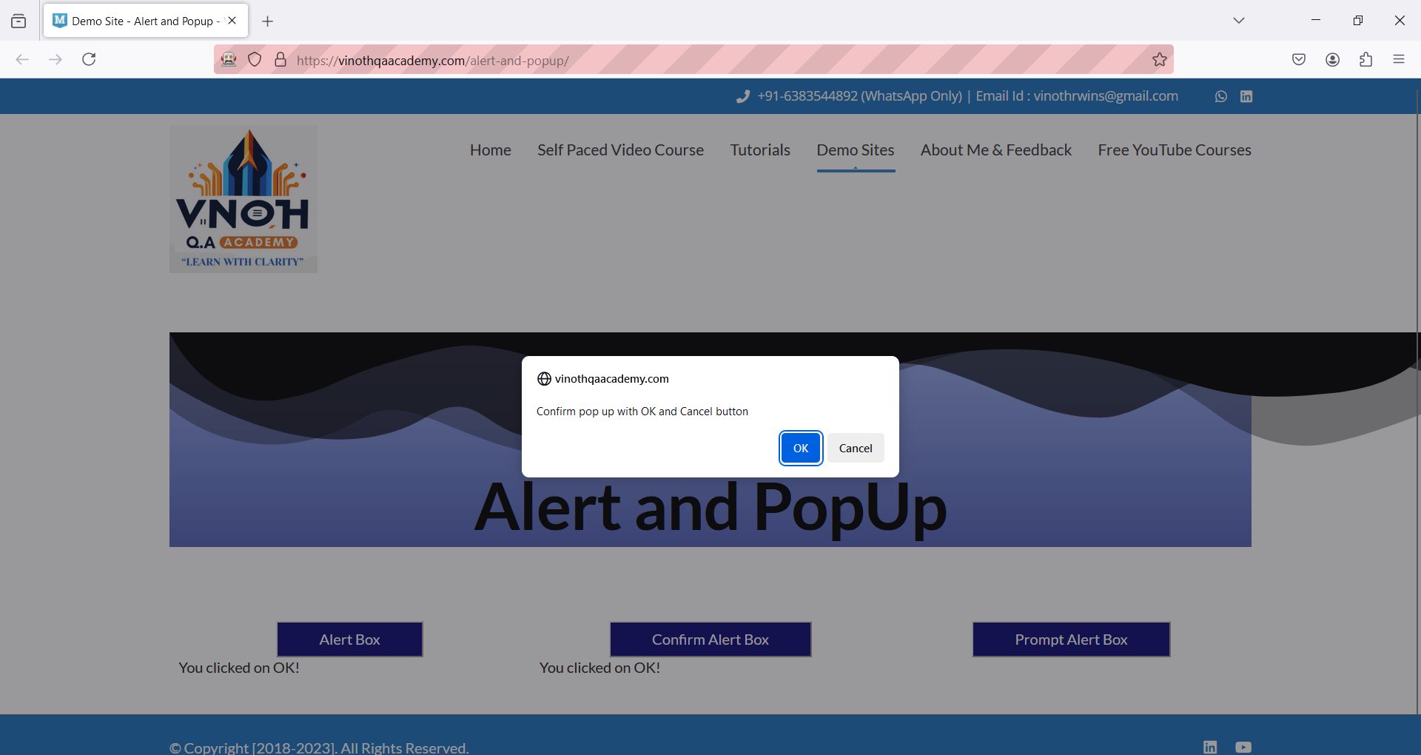

**3] Prompt Alertbox**

**Code:**

**import** org.openqa.selenium.Alert;

**import** org.openqa.selenium.By;

**import** org.openqa.selenium.WebDriver;

**import** org.openqa.selenium.chrome.ChromeDriver;

**import** org.openqa.selenium.firefox.FirefoxDriver;

**import** org.testng.annotations.BeforeClass;

**import** org.testng.annotations.Test;

**public** **class** PromptAlertbox {

WebDriver wd;

@BeforeClass

**public** **void** setup()

{

System.*setProperty*("webdriver.chrome.driver", "D:\\Selenium\\chromedriver-win64\\chromedriver.exe");

WebDriver wd = **new** FirefoxDriver();

wd.get("https://vinothqaacademy.com/alert-and-popup/");

}

@Test

**public** **void** testAlertInput() **throws** InterruptedException

{

wd.findElement(By.*name*("promptalertbox1234")).click(); // Assuming there's a prompt box

Thread.*sleep*(2000); // Wait for the alert to appear

// Handle the prompt dialog

String inputText = "Yes"; // Simulated user input

wd.switchTo().alert().sendKeys(inputText); // Send input to the alert

Alert alt = wd.switchTo().alert();

System.***out***.println("Text of Alert " + alt.getText());//capture text

alt.accept(); // Click OK

}

}

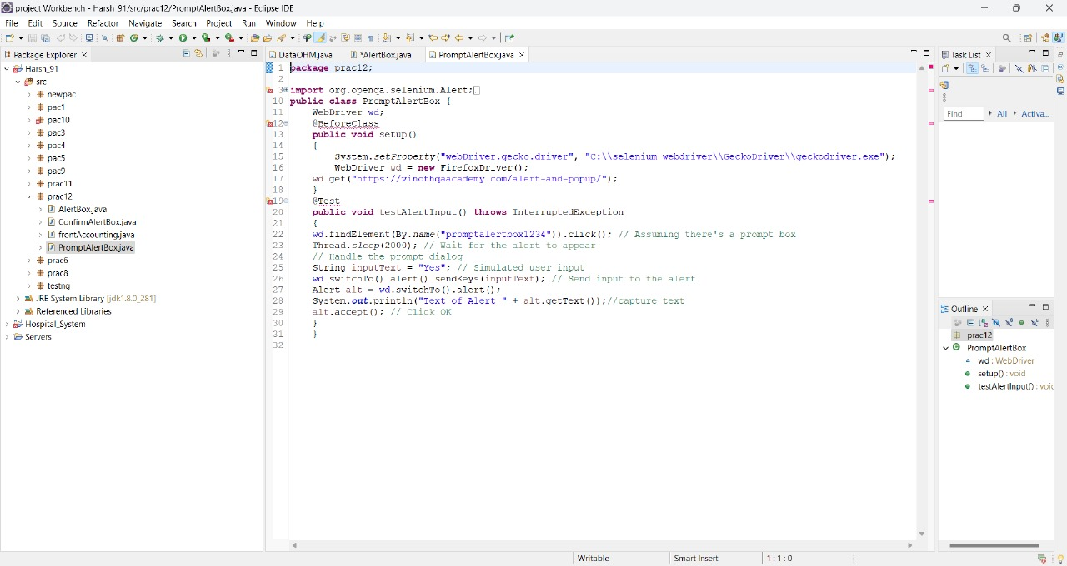

**Output:**

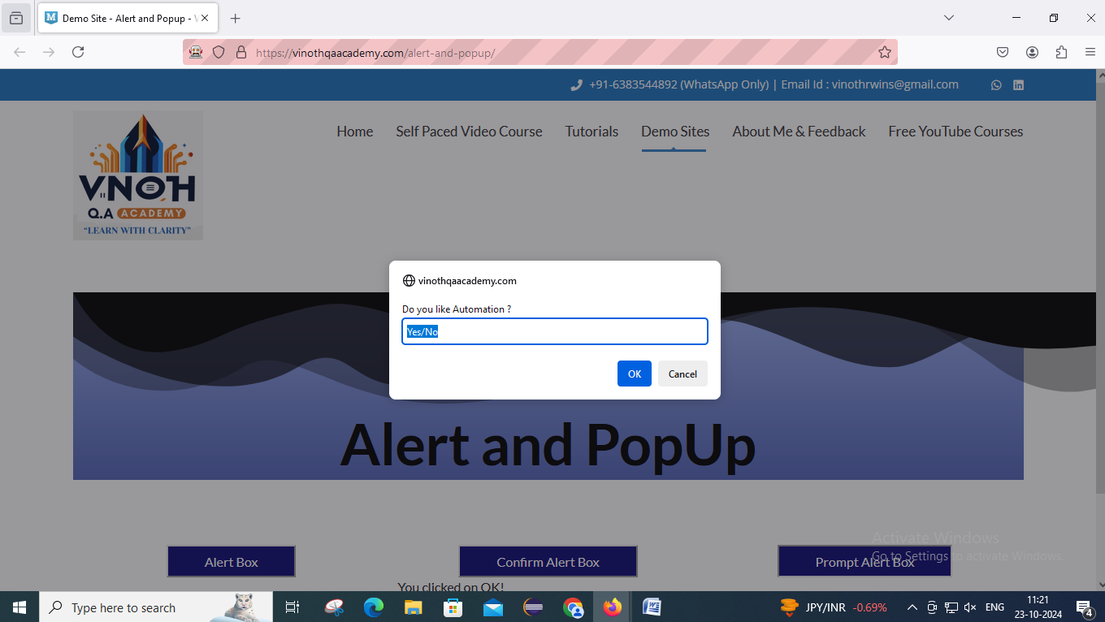

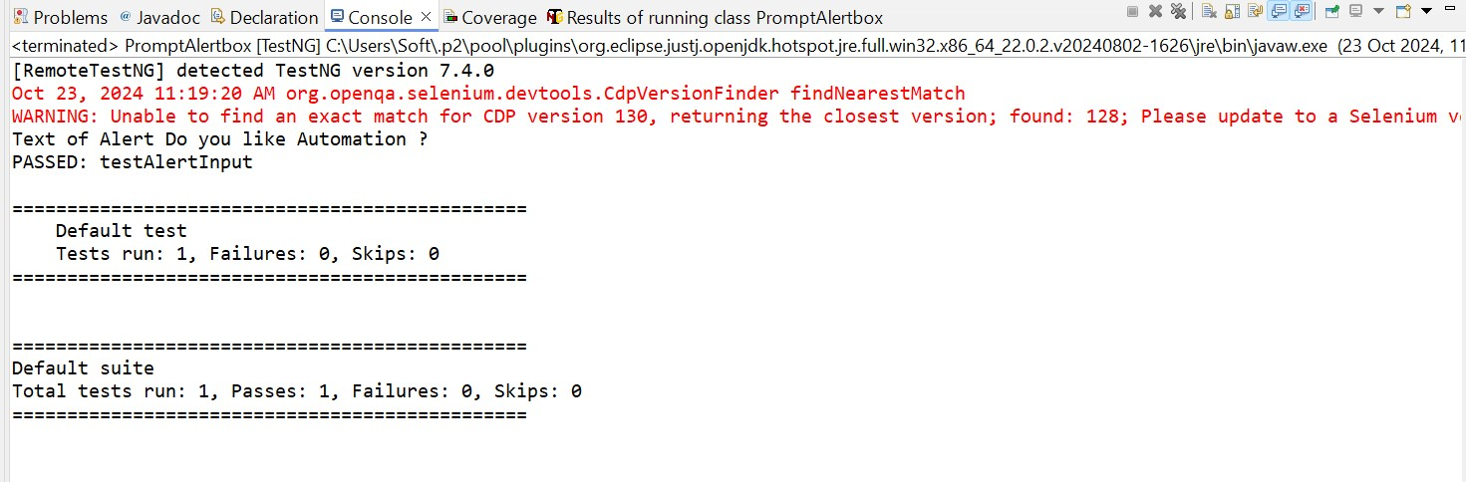

**G) DemoOHM**

**Code:**

**package** testng;

**import** java.util.concurrent.TimeUnit;

**import** org.openqa.selenium.By;

**import** org.openqa.selenium.WebDriver;

**import** org.openqa.selenium.firefox.FirefoxDriver;

**import** org.testng.annotations.AfterClass;

**import** org.testng.annotations.AfterSuite;

**import** org.testng.annotations.BeforeClass;

**import** org.testng.annotations.BeforeSuite;

**import** org.testng.annotations.Test;

**public** **class** DataOHM1

{

WebDriver wd;

@BeforeSuite

**public** **void** openBrowser()

{

System.*setProperty*("webdriver.chrome.driver","C:\\\\selenium web driver\\\\ChromeDriver\\\\chromedriver-win64\\\\chromedriver-win64\\\\geckodriver.exe");

wd = **new** FirefoxDriver();

}

@BeforeClass

**public** **void** loginOHM()

{

wd.get("https://opensource-demo.orangehrmlive.com/");

wd.manage().timeouts().~~implicitlyWait~~(10, TimeUnit.***SECONDS***);

wd.findElement(By.*name*("username")).sendKeys("admin");//locator id

wd.findElement(By.*name*("password")).sendKeys("admin123");//locater name

wd.findElement(By.*className*("oxd-button")).click();//locatorclassName

}

@Test(priority = 2)

**public** **void** myInfo()

{

wd.findElement(By.*className*("oxd-main-menu-item")).click();

}

@Test(priority = 1)

**public** **void** pim()

{

wd.findElement(By.*className*("oxd-main-menu-item")).click();

}

@AfterClass

**public** **void** logoutOHM() **throws** Exception

{

wd.findElement(By.*className*("oxd-userdropdown-name")).click();//locator partiallinkText

Thread.*sleep*(2000);

wd.findElement(By.*partialLinkText*("Logout")).click();//locatorlinkText

}

@AfterSuite

**public** **void** closeBrowser()

{

wd.quit();

}

}

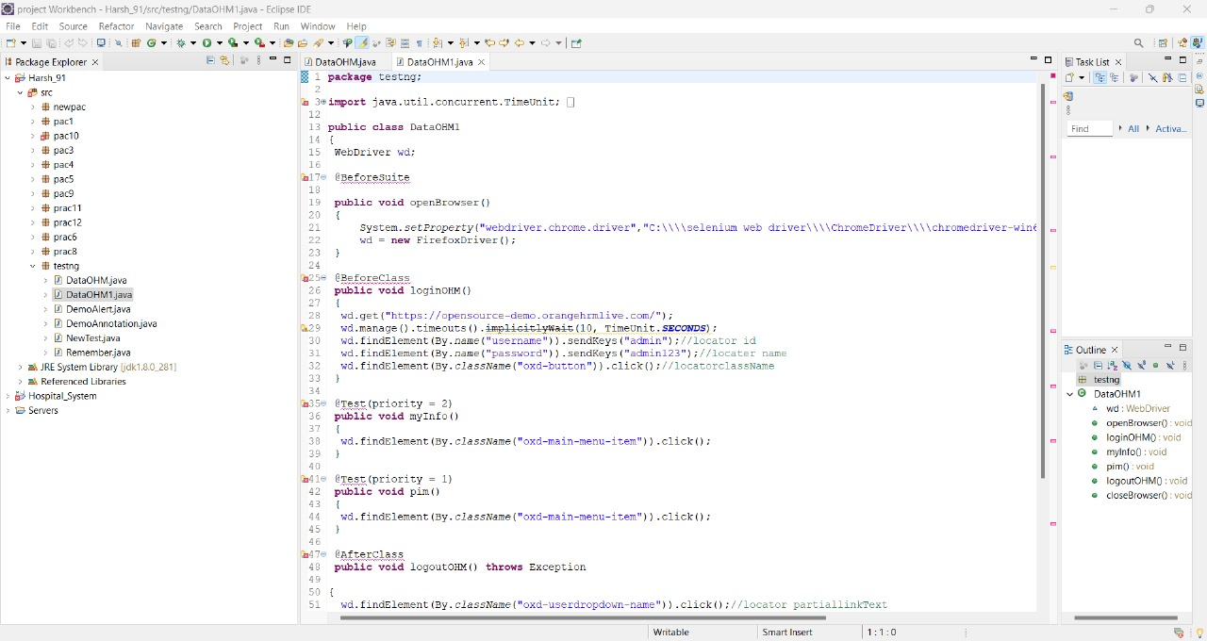

**Output:**



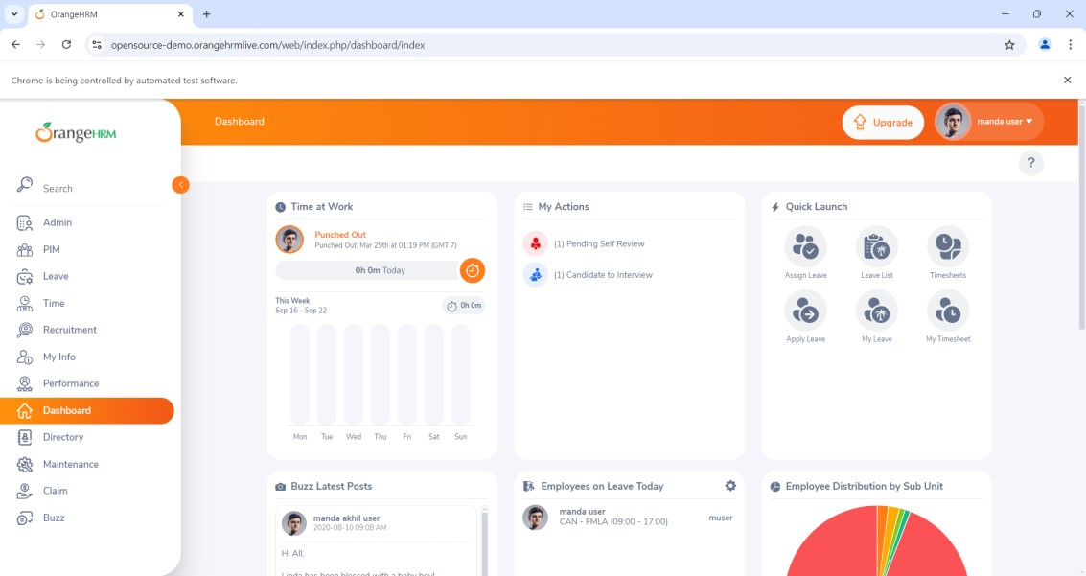

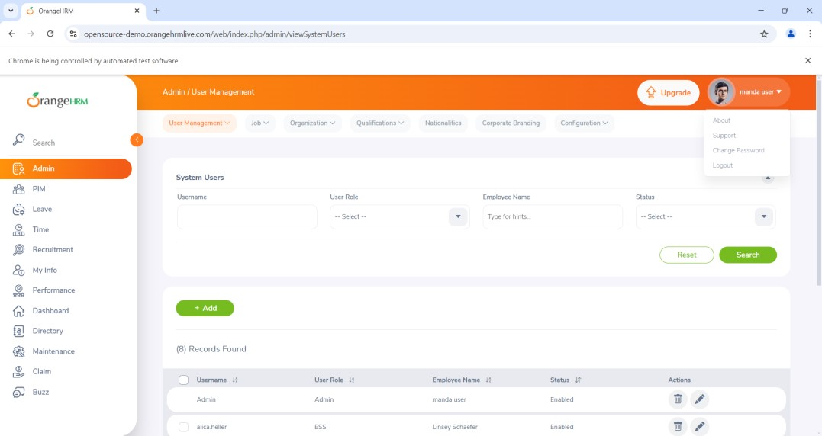

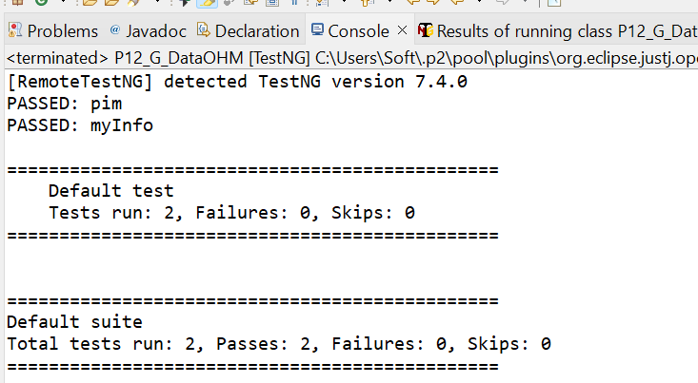

**Practical No: 13**

**Aim: Demonstrate Data Driven Framework.**

**1] File read data from Excel and perform testing using selenium.**

**Code:**

package Harsh_91;

import java.io.FileInputStream;

import java.io.IOException;

import org.apache.poi.xssf.usermodel.XSSFCell;

import org.apache.poi.xssf.usermodel.XSSFRow;

import org.apache.poi.xssf.usermodel.XSSFSheet;

import org.apache.poi.xssf.usermodel.XSSFWorkbook;

public class prac7{

public static void main(String[] args) throws IOException{

// TODO Auto-generated method stub

FileInputStream fis = new FileInputStream("C:\\Users\\lab-38\\Documents\\Excel91.xlsx");

XSSFWorkbook wb = new XSSFWorkbook(fis);

XSSFSheet sh = wb.getSheet("Sheet1");

for(int i = 1; i <= sh.getLastRowNum(); i++)

{

XSSFRow rw = sh.getRow(i);

XSSFCell un = rw.getCell(0);

XSSFCell pw = rw.getCell(1);

XSSFCell gn = rw.getCell(2);

System.out.println("Username ---->" + un + " " + "Password ---->" + pw + " " + "Result ---->" + gn);

}

wb.close();

}

}

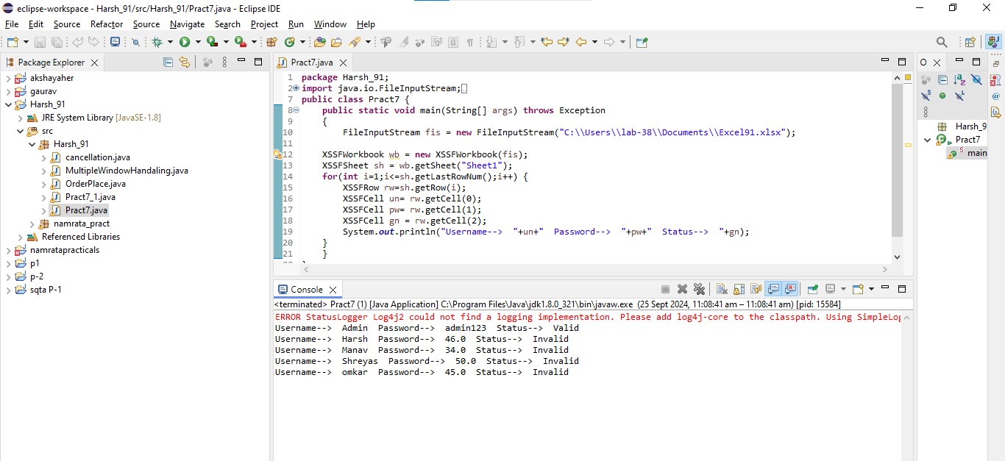

**Output:**

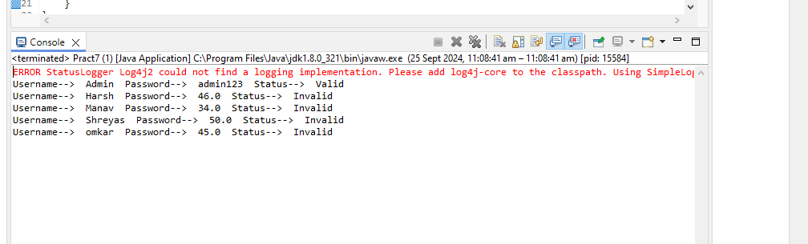

**2] Write a Program to Read data from an Excel file and login in to site.**

**Code:**

package Harsh_91;

import java.io.FileInputStream;

import java.io.FileOutputStream;

import java.util.concurrent.TimeUnit;

import org.apache.poi.xssf.usermodel.XSSFCell;

import org.apache.poi.xssf.usermodel.XSSFRow;

import org.apache.poi.xssf.usermodel.XSSFSheet;

import org.apache.poi.xssf.usermodel.XSSFWorkbook;

import org.openqa.selenium.By;

import org.openqa.selenium.WebDriver;

import org.openqa.selenium.firefox.FirefoxDriver;

public class Prac7_1{

public static void main(String[] args) throws Exception {

// TODO Auto-generated method stub

System.setProperty("webdriver.chrome.driver","C:\\selenium webdriver\\GeckoDriver\\geckodriver.exe");

WebDriver wd = new FirefoxDriver();

wd.get("https://opensource-demo.orangehrmlive.com/");

FileInputStream fis = new FileInputStream("C:\\Users\\lab-38\\Documents\\Excel91.xlsx");

XSSFWorkbook wb = new XSSFWorkbook(fis);

XSSFSheet sh = wb.getSheet("Sheet1");

for(int i=1; i<=sh.getLastRowNum(); i++)

{

XSSFRow rw = sh.getRow(i);

XSSFCell un = rw.getCell(0);

XSSFCell pw = rw.getCell(1);

XSSFCell res = rw.createCell(2);

System.out.println("Username ----->" + un + "Password -----> " + pw );

wd.manage().timeouts().implicitlyWait(6,TimeUnit.SECONDS);

wd.findElement(By.name("username")).sendKeys(un.toString());

wd.findElement(By.name("password")).sendKeys(pw.toString());

wd.findElement(By.className("oxd-button")).click();

try {

wd.findElement(By.className("oxd-userdropdown-name")).click();

wd.findElement(By.partialLinkText("Logout")).click();

System.out.println("Login Pass");

res.setCellValue("Valid");

}

catch (Exception e)

{

System.out.println("Login Fail");

res.setCellValue("Invalid");

}

}

FileOutputStream fos = new FileOutputStream("C:\\Users\\lab-38\\Documents\\Excel91.xlsx");

wb.write(fos);

fis.close();

}

}

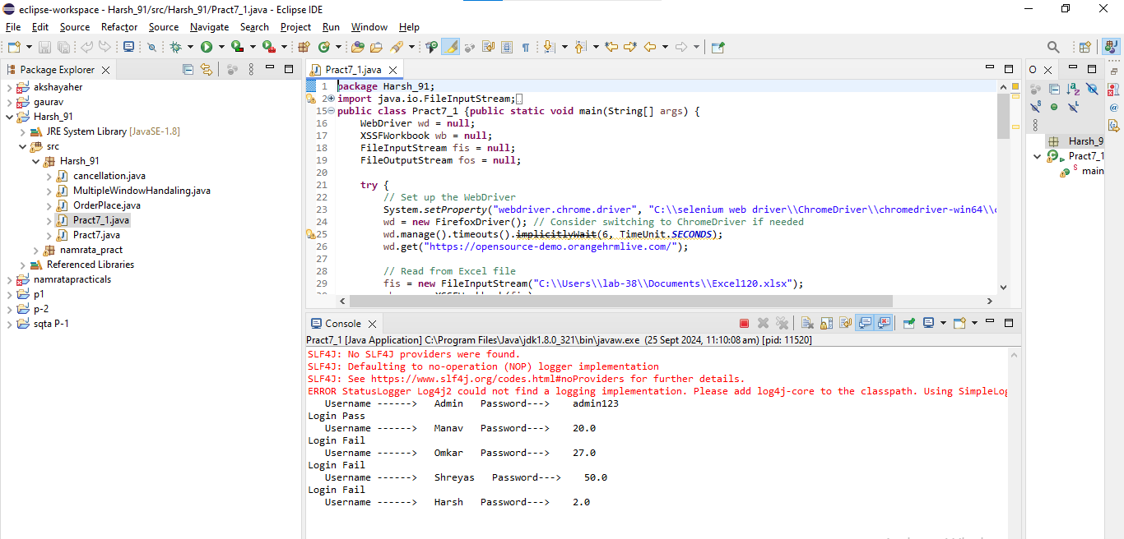

**Output:**

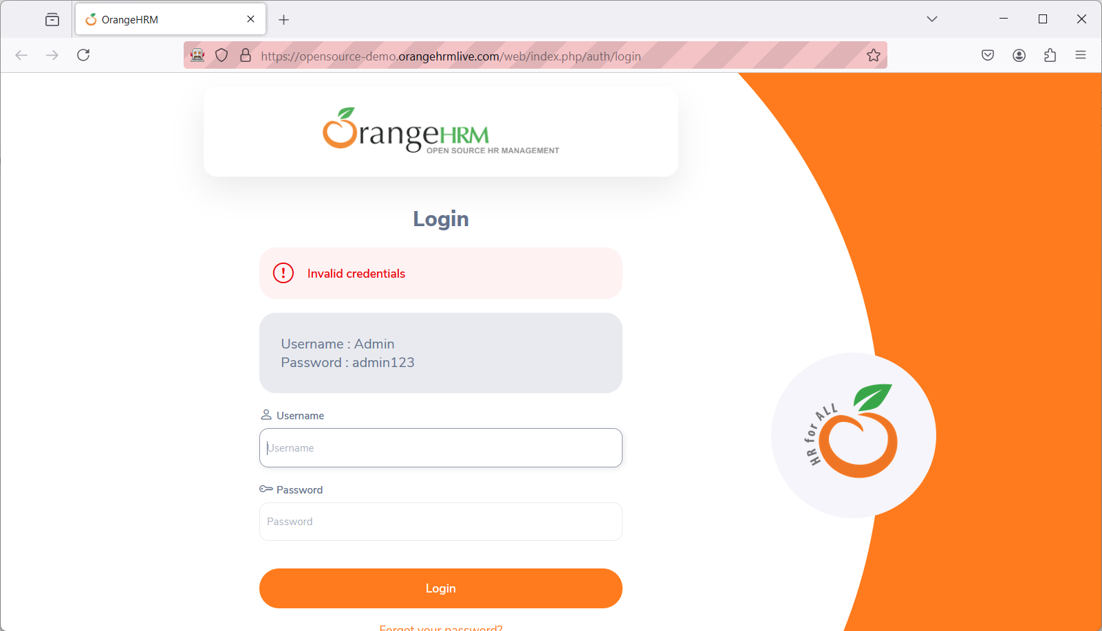

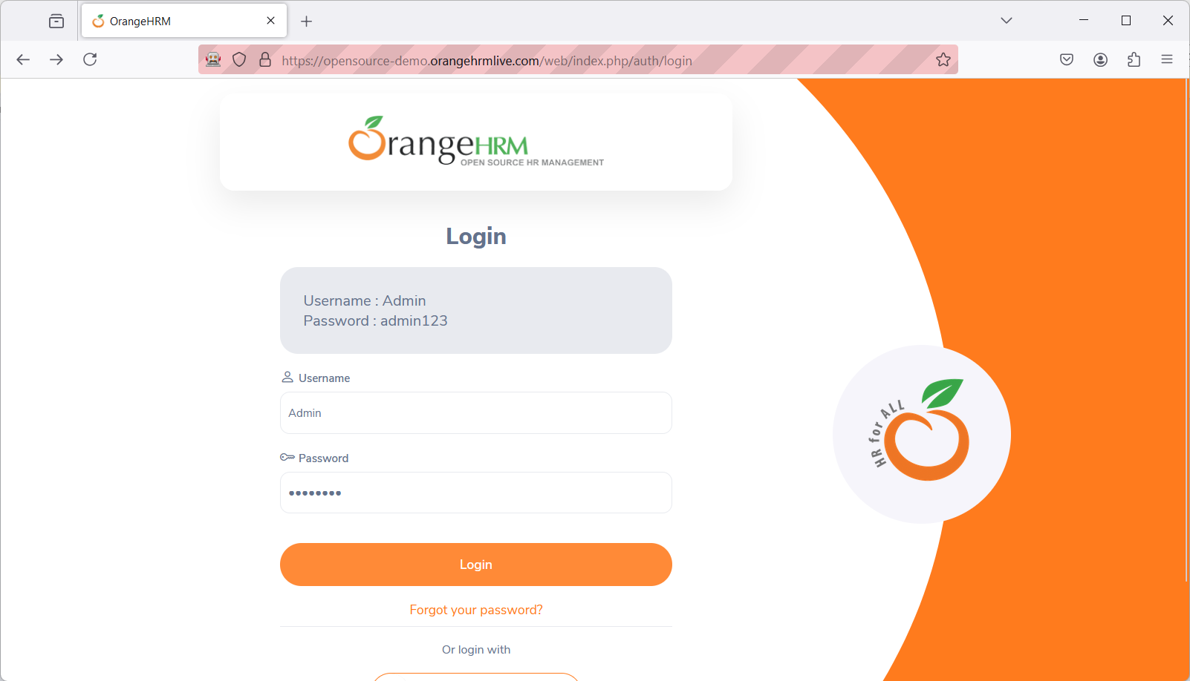

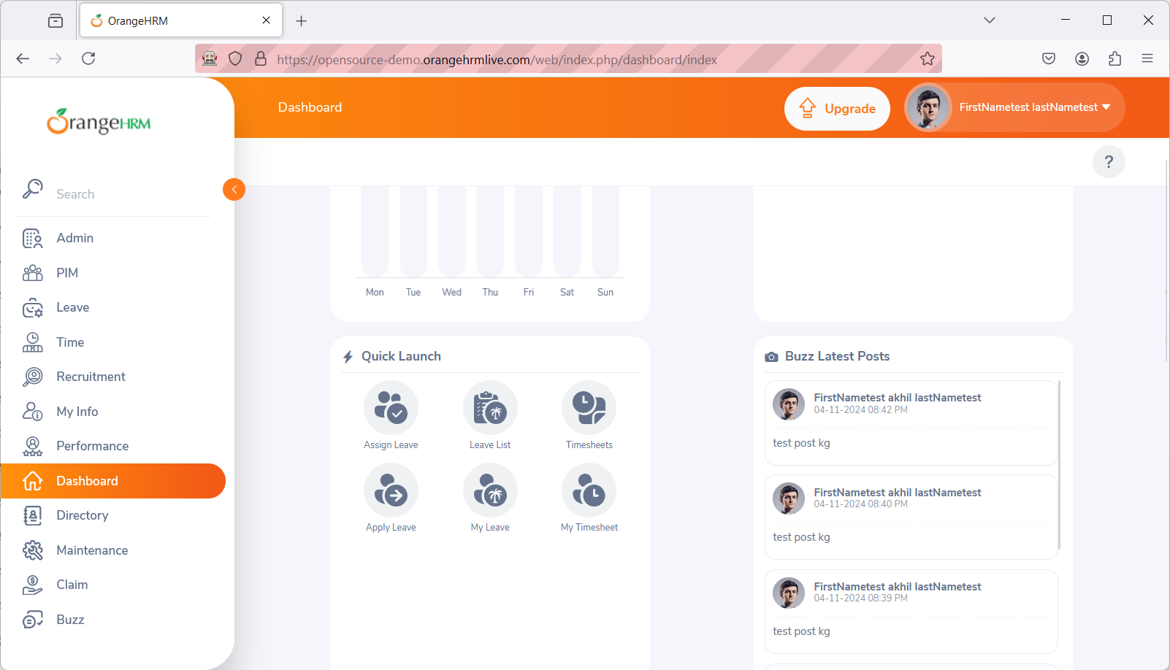

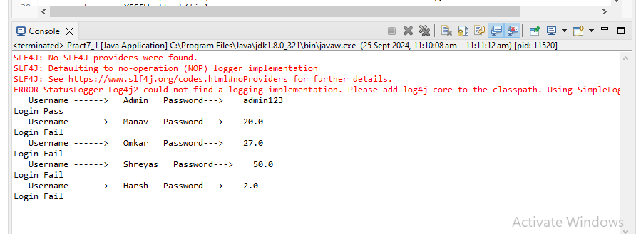

**Practical No 14**

**Aim: Validation testing using chrome and bing**

Code:

package Selenium;

import org.openqa.selenium.By;

import org.openqa.selenium.Keys;

import org.openqa.selenium.WebDriver;

import org.openqa.selenium.chrome.ChromeDriver;

import org.openqa.selenium.firefox.FirefoxDriver;

public class validation {

public static void main(String[] args) throws Exception

{

System.setProperty("webdrive.gecko.driver.","C:\\selenium web driver\\ChromeDriver\\chromedriver-win64\\chromedriver-win64\\geckodriver.exe");

WebDriver wd= new FirefoxDriver();

wd.get("https://www.google.com/");

Thread.sleep(2000);

wd.findElement(By.className("gyFyf")).sendKeys("Fruits");

wd.findElement(By.className("gLFyf")).sendKeys(Keys.ENTER);

}

}

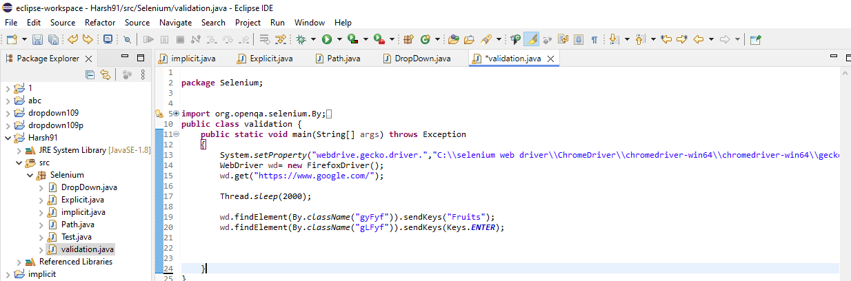

Output:

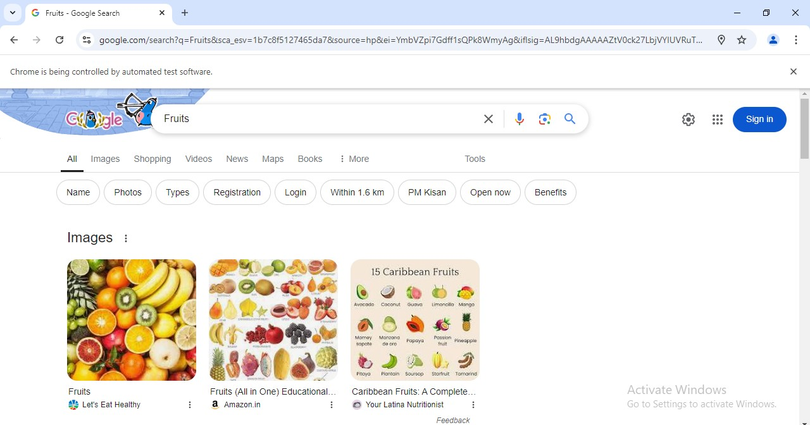

**Bing**

Code:

package Selenium;

import org.openqa.selenium.Keys;

import org.openqa.selenium.By;

import org.openqa.selenium.WebDriver;

import org.openqa.selenium.chrome.ChromeDriver;

class Prac8 {

public static void main(String[] args)throws Exception

{

System.setProperty("webdriver.chrome.driver","E:\\chromedriver-win64\\chromedriver.exe");

WebDriver wd=new ChromeDriver();

wd.get("https://www.bing.com/");

Thread.sleep(2000);

wd.findElement(By.className("gLFyf")).sendKeys("Fruits");

wd.findElement(By.className("gLFyf")).sendKeys(Keys.ENTER);

}

}

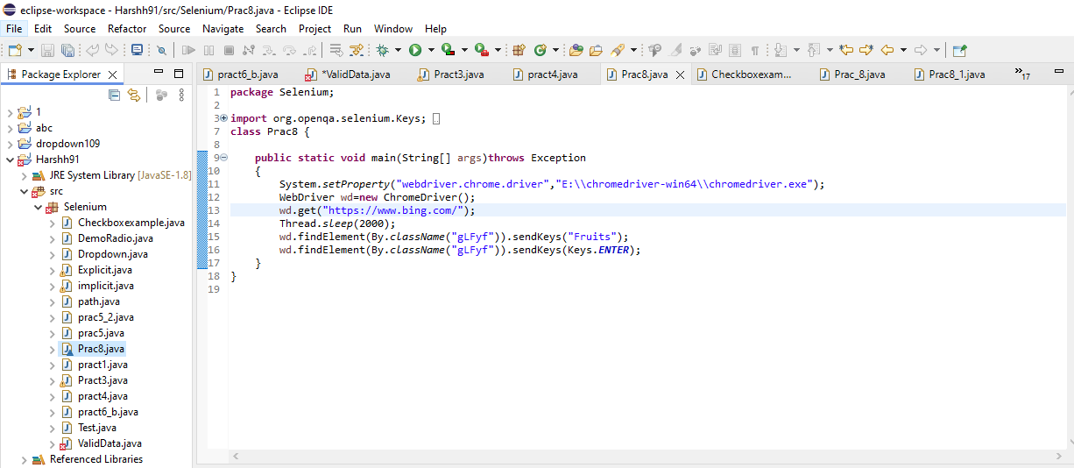

Output:

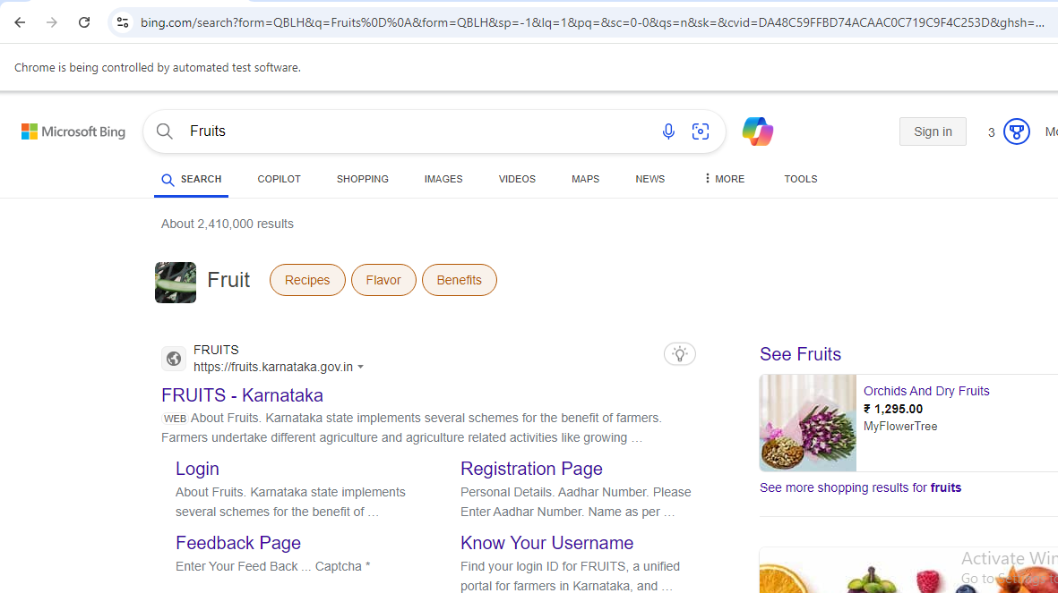

**Practical No: 15**

**Aim: Perform Regression Testing.**

**Theory:**

**What is Regression Testing?**

REGRESSION TESTING is defined as a type of software testing to confirm that a recent program or code change has not adversely affected existing features.

Regression Testing is nothing but a full or partial selection of already executed test cases which are re-executed to ensure existing functionalities work fine.

This testing is done to make sure that new code changes should not have side effects on the existing functionalities. It ensures that the old code still works once the latest code changes are done.

**Need of Regression Testing**

The Need of Regression Testing mainly arises whenever there is requirement to change the code and we need to test whether the modified code affects the other part of software application or not.

Moreover, regression testing is needed, when a new feature is added to the software application and for defect fixing as well as performance issue fixing.

**How to do Regression Testing**

In order to do Regression Testing process, we need to first debug the code to identify the bugs.

Once the bugs are identified, required changes are made to fix it, then the regression testing is done by selecting relevant test cases from the test suite that covers both modified and affected parts of the code.

Software maintenance is an activity which includes enhancements, error corrections,optimization and deletion of existing features. These modifications may cause the system to work incorrectly. Therefore, Regression Testing becomes necessary.

**Regression Test Selection**

Regression Test Selection is a technique in which some selected test cases from test suite are executed to test whether the modified code affects the software application or not.

Test cases are categorized into two parts, reusable test cases which can be used in further regression cycles and obsolete test cases which can not be used in succeeding cycles.